Copyright

by

Almon David Ing, PhD

2010, 2011, 2012

MoRPE: A Probabilistic Classifier

by

Almon David Ing, PhD

Center for Perceptual Systems, University of Texas at Austin

# Abstract

The c*lassification problem* is commonly encountered when a finite sample of data is leveraged to determine the probabilistic relationship between a category label $c$ and a multivariate coordinate $\text{x}$ for an entire population. Solving this problem requires approximating the *optimal classifier*, a function of $\text{x}$ that evaluates the conditional probability $p\left(c | \text{x}\right)$ in an optimal way. This paper introduces MoRPE, a new method for approximating optimal classifiers. MoRPE is a machine learning method for probabilistic classification based on Monotonic Regression of a Polynomial Expansion. It is conceptually related to Fisher’s Quadratic Discriminant (Fisher 1936). MoRPE has the ability to approximate an optimal classifier with remarkable precision in common scenarios.

# Introduction

Many scientists and engineers are familiar with the *classification problem*. This problem arises when a machine must categorize an input signal by assigning a category label. Any machine that performs this function can be called a *classifier*. Three examples of classifiers are listed below.

* A computer that spots cancer in mammograms.
  + For each location in the mammogram, the computer must assign the category of *cancer present* or *cancer absent.*
* An Unmanned Aerial Vehicle (UAV) that spots targets on the ground.
  + For each field of view, the UAV must assign the category of *target present* or *target absent*.
* A monkey that searches for edible fruit.
  + For each object viewed, the monkey must assign the category of *fruit* or *not fruit.*

In real-world scenarios, classifiers are capable of making errors. For any classifier to be optimal, it must estimate its uncertainty whenever it renders a decision. In other words, it should be a *probabilistic classifier*, with the ability to estimate the conditional probability $p\left(c | \text{x}\right)$ of membership in any category $c$ as a function of the given input $\text{x}$. The input signal **x** is often called the *feature vector* (e.g. Duda et al. 2001) and **x**-space is often called the *feature space*.

Here I introduce MoRPE, a machine learning method for training and implementing probabilistic classifiers. MoRPE is based on the Monotonic Regression of a Polynomial Expansion. In common scenarios, MoRPE can approximate the probability of category membership with remarkable precision. I believe this level of precision is unprecedented when compared to standard alternatives.[1]

## History

One of MoRPE’s earliest ancestors is the Fisher Quadratic Discriminant (FQD). Fisher (1936) developed the FQD for classifying multivariate signals in cases where two categories are possible $\left\{1,2\right\}$ and where each category is distributed as a multivariate Gaussian with known means $\left\{μ_{1}\text{,}μ_{2}\right\}$ and covariance matrices $\left\{Σ_{1}\text{,}Σ_{2}\right\}$. Figure 1 provides a summary illustration of Fisher’s solution to the classification problem.

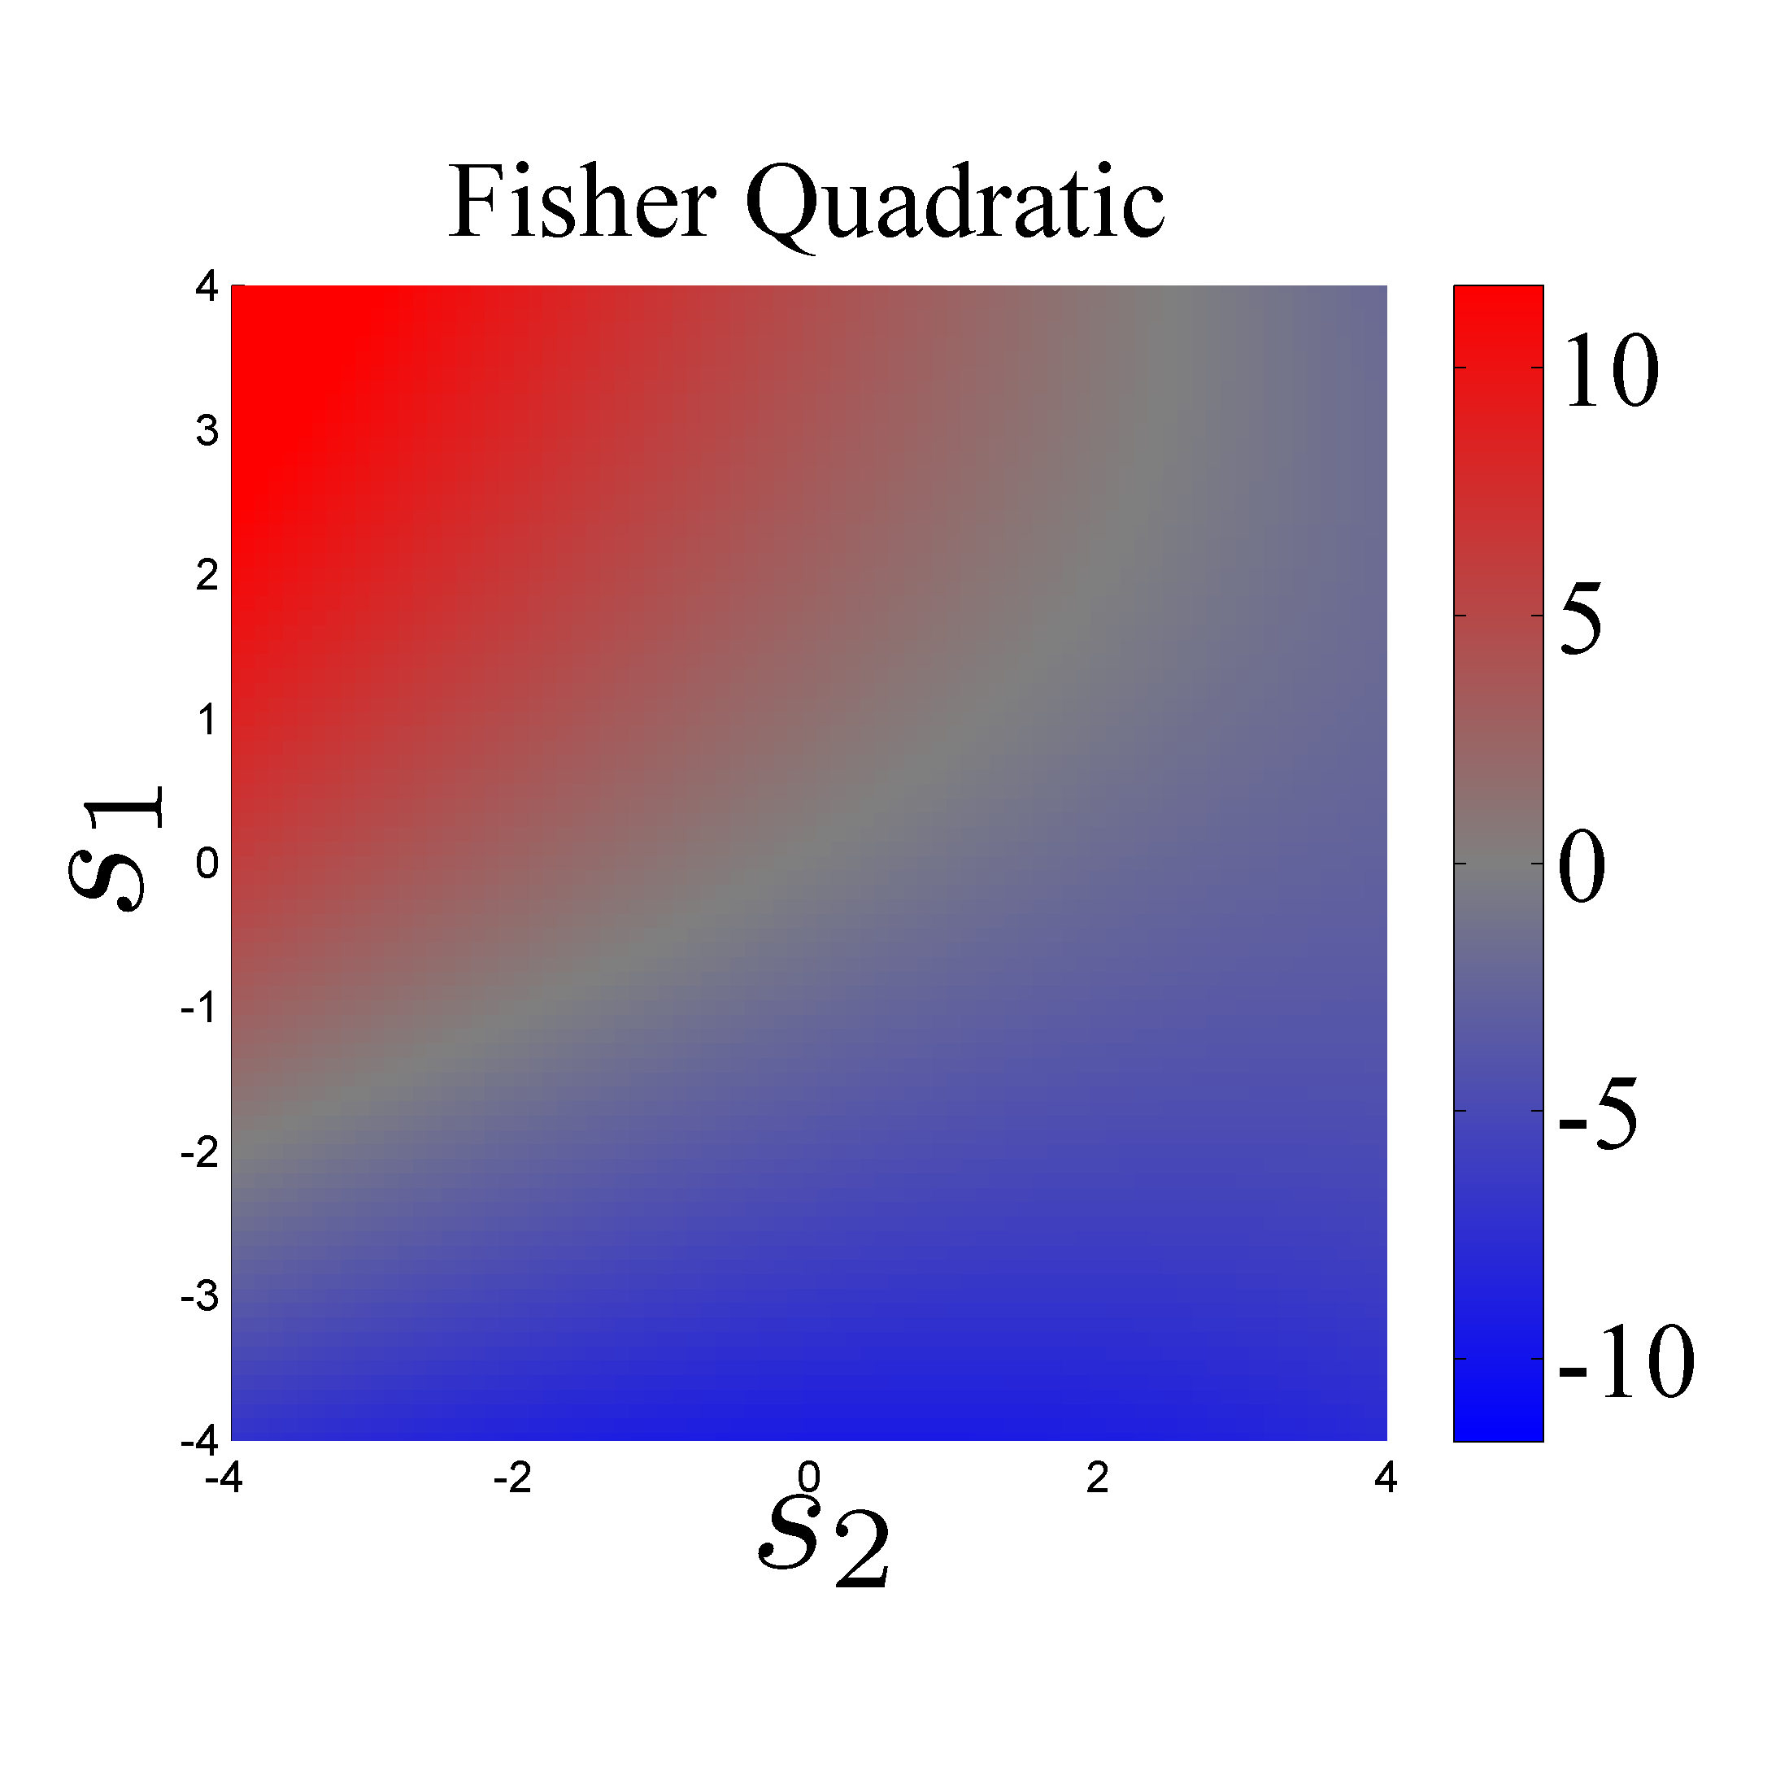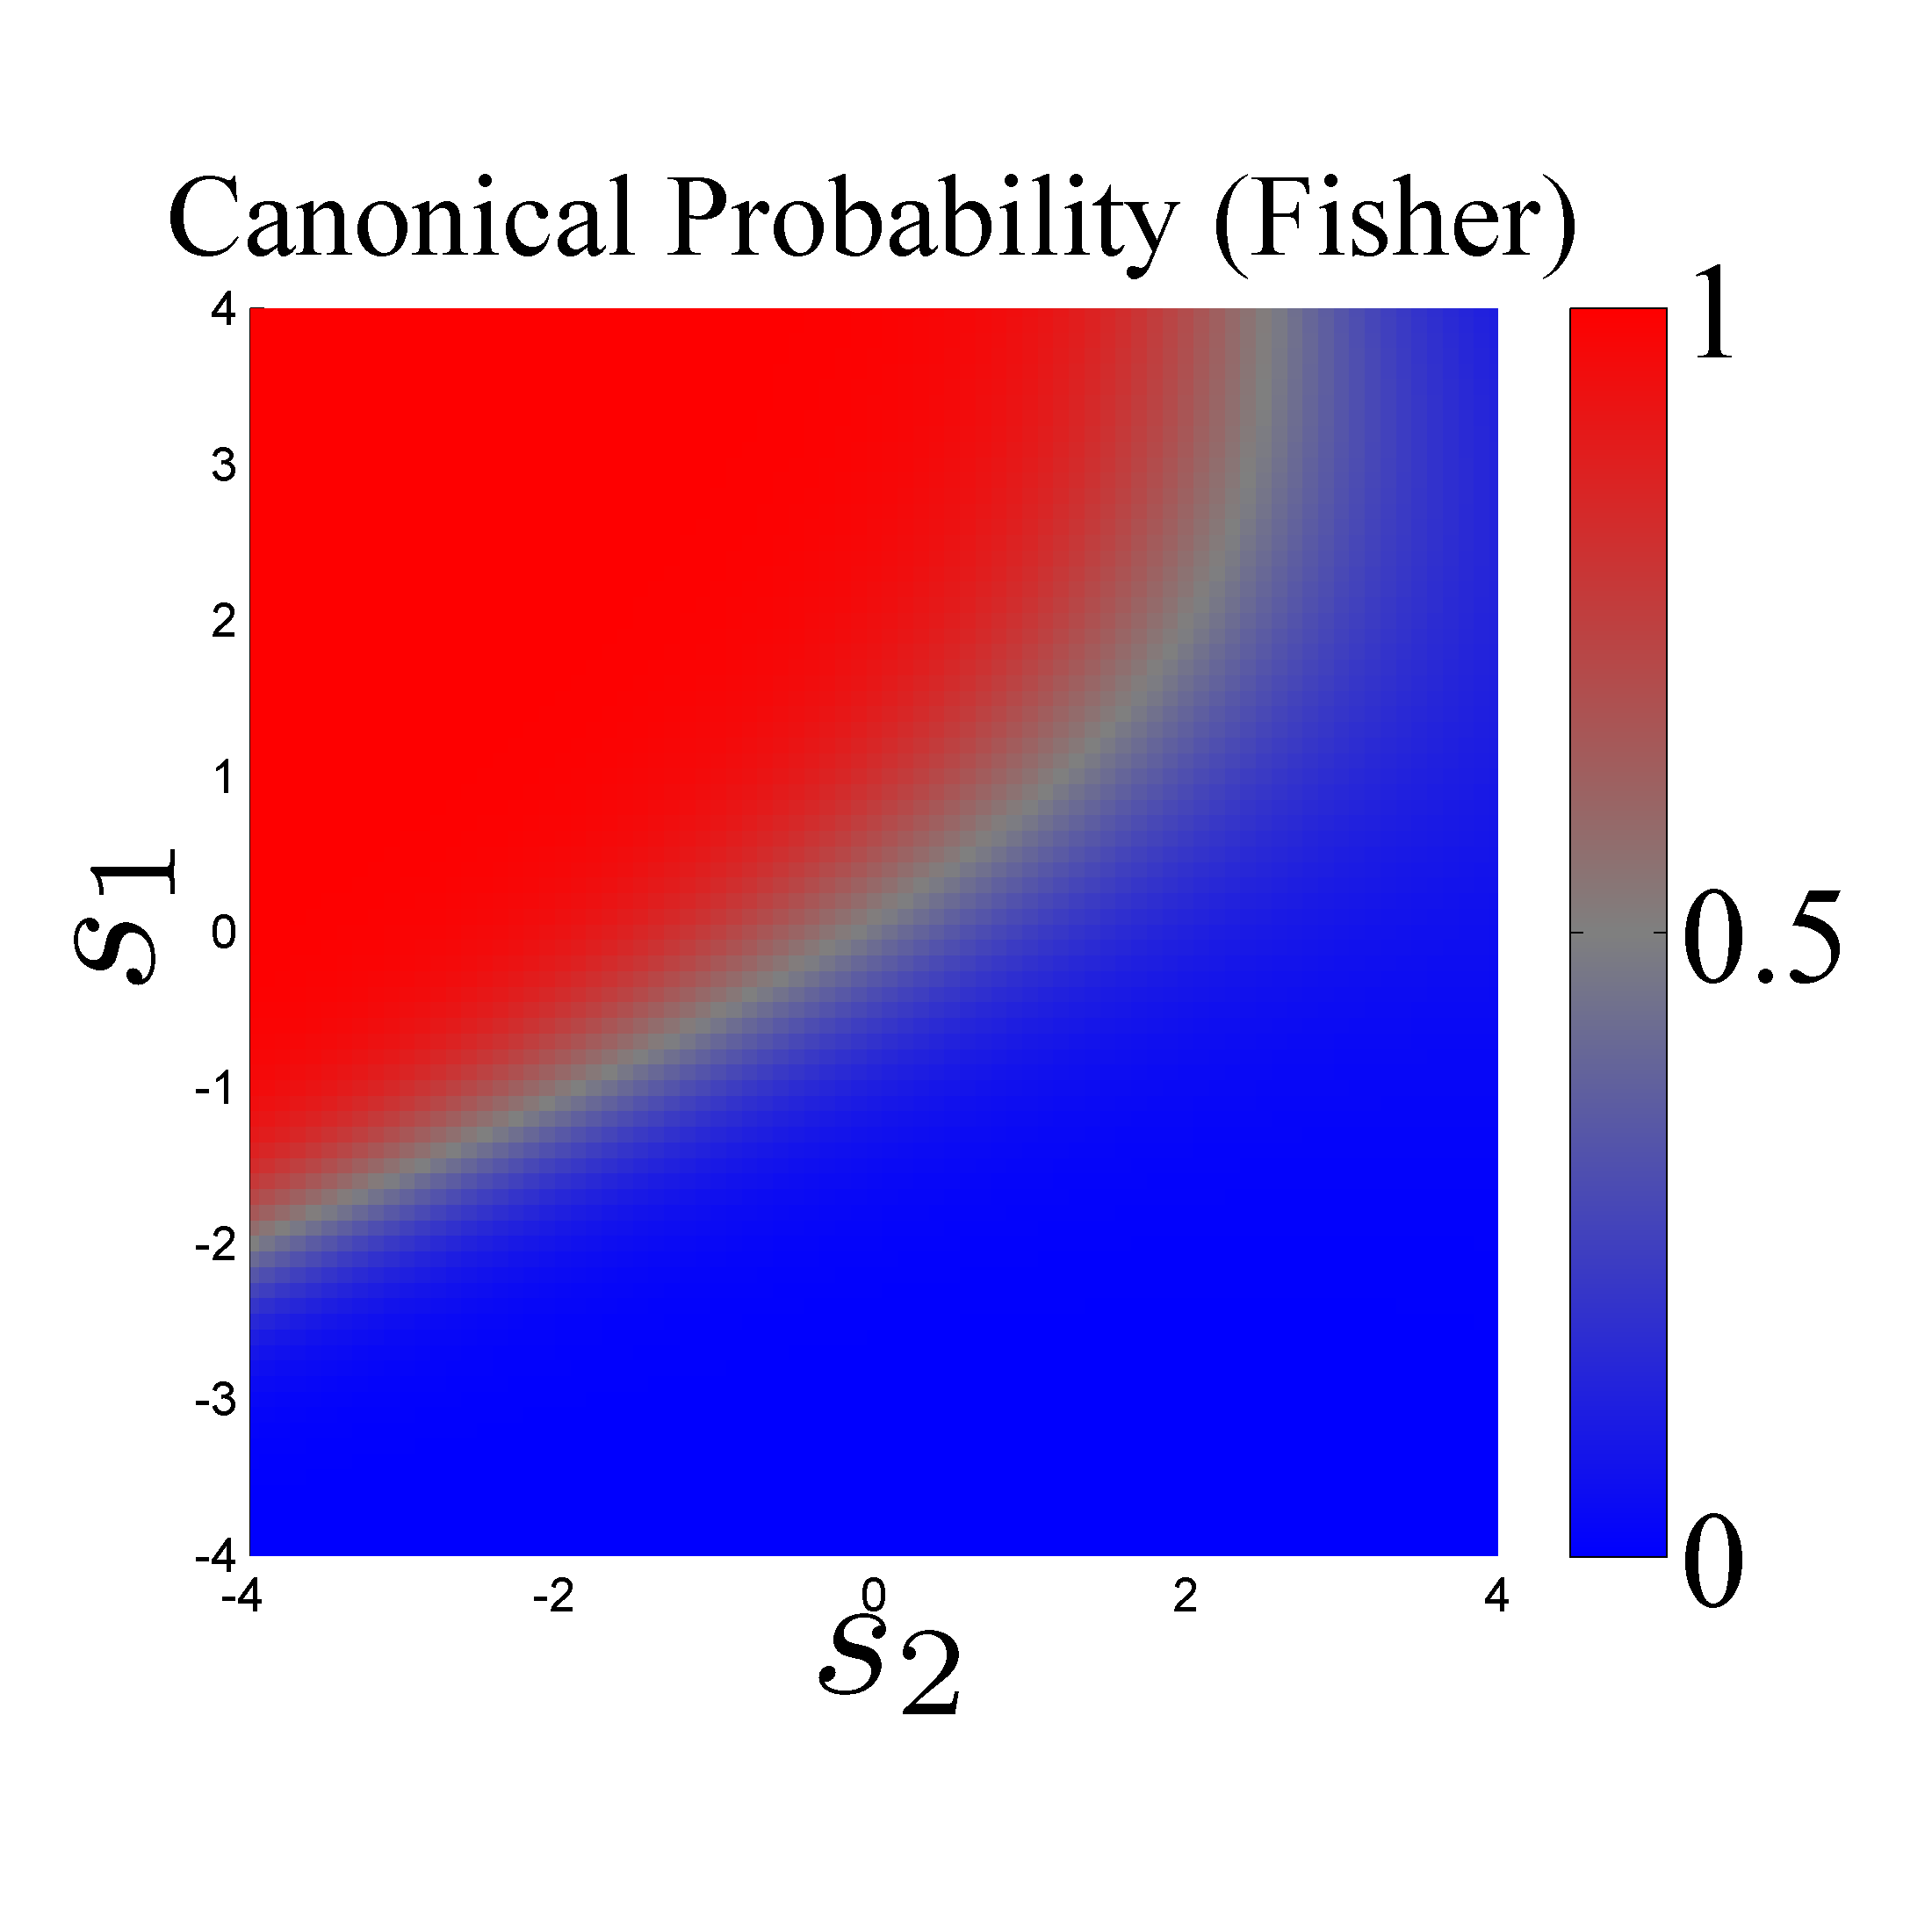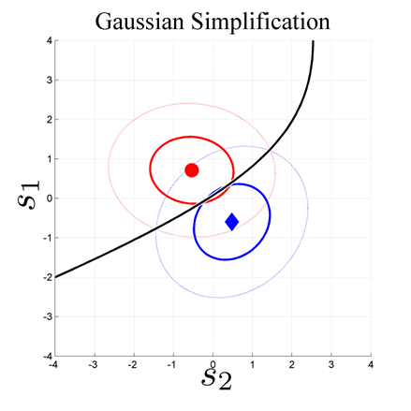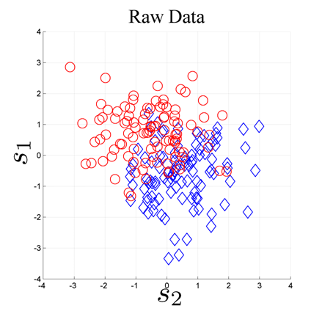

**A**

**B**

**C**

**D**

*x*1

*x*2

*x*1

*x*1

*x*1

*x*2

*x*2

*x*2

Figure 1. The Fisher Quadratic Discriminant (FQD) is illustrated for a hypothetical sample of 2-category classification data. Each datum has a category label (1=*red* or 2=*blue*) and two continuous values $x_{1}$ and $x_{2}$. The samples are taken from Gaussian categories. **A.** The sample is depicted in a scatterplot. **B.** The sample mean and covariance matrices are illustrated with the optimal decision boundary. **C.** The FQD (a quadratic function) can be determined if the means and covariance matrices are known. The optimal decision boundary (shown in figure B) corresponds to a single value of the FQD. **D.** The conditional probability of category membership is computed directly from the FQD using the logistic sigmoid transform.

Fisher assumes that the probability density of each distribution is a multivariate Gaussian. This means that the density of each distribution is specified as follows where *D* is the dimensionality of the feature space (i.e. the length of **x**).

|  |  |
| --- | --- |
|  | (1) |

|  |  |
| --- | --- |
|  | (2) |

Fisher’s key insight was that the log of the ratio of probability densities can be specified as

|  |  |
| --- | --- |
|  | (3) |

where

|  |  |
| --- | --- |
|  | (4) |

The expression above is often called the *Fisher Quadratic Discriminant* (FQD, see Ashby 1992 p. 463). The FQD is a multivariate quadratic function (i.e. a polynomial of rank 2). The FQD is often used with the *logistic sigmoid transform* (eq. 5) in order to implement a probabilistic classifier as suggested by eq. 6.

|  |  |
| --- | --- |
| $$f\left(y\right)≡ \frac{1}{1+exp\left(-y\right)}$$ | (5) |

|  |  |
| --- | --- |
|  | (6) |

In Fisher’s scenario, where both categories are Gaussian with known means and covariance matrices, equations 3-6 are true. Unfortunately, in common scenarios[2], Fisher’s assumptions are often violated or cannot be verified. In such cases, equation 6 cannot be regarded as true. It can only be regarded as an imprecise estimate of conditional probability.

Over time, newer methods have tried to compensate for this problem. One of these methods is called logistic regression (e.g. Hastie et al. 2008). Other methods include Ridge Regression (e.g. Foster 1961, Hoerl 1962), the Soft-margin Support Vector Machine (Cortes & Vapnik 1995), the Relevance Vector Machine (Tipping 2001), and more general Kernel Machines (e.g. Shawne-Taylor & Cristianini 2004).

This paper introduces a new method called MoRPE which is based on Monotonic Regression of a Polynomial Expansion. When MoRPE is applied in common scenarios, it can be used estimate the conditional probability of category membership with remarkable precision and reliability.

## Sampling Noise and Fragmentation

Before I explain how MoRPE works, I want to explain a fundamental characteristic of the classification problem. All classifiers must contend with a fundamental nuisance called *sampling noise[3]* which is the basis of all statistical uncertainty. In the context of optimization and machine learning, this nuisance corrupts all possible fitting procedures, so classifiers always tend to *overfit* a given sample.

This nuisance (caused by sampling noise) enforces a limit on any classifier’s *flexibility* or its ability to accommodate various patterns in data. As the classifier’s flexibility increases, so does its tendency to overfit a sample (at an increasing rate). We might call this a *flexibility-overfitting tradeoff*, but it is more commonly called the *bias-variance tradeoff* (e.g. Bishop 2006).

Since flexibility is limited (by the tradeoff), it is the analyst’s job to design a feature space where the effects of sampling noise can be minimized. The analyst’s definition of a feature space is not arbitrary because it affects MoRPE’s performance. As a general rule of thumb, a good feature space is one that minimizes *category fragmentation*.

What is *category fragmentation*? Figure 2 depicts three scenarios. In the first scenario (fig. 2A), the categories are fragmented because they are composed of disjoint clusters intermingled with clusters from other categories. Fragmentation increases the mutual relative adjacency of observations from different categories in each neighborhood of **x**-space.

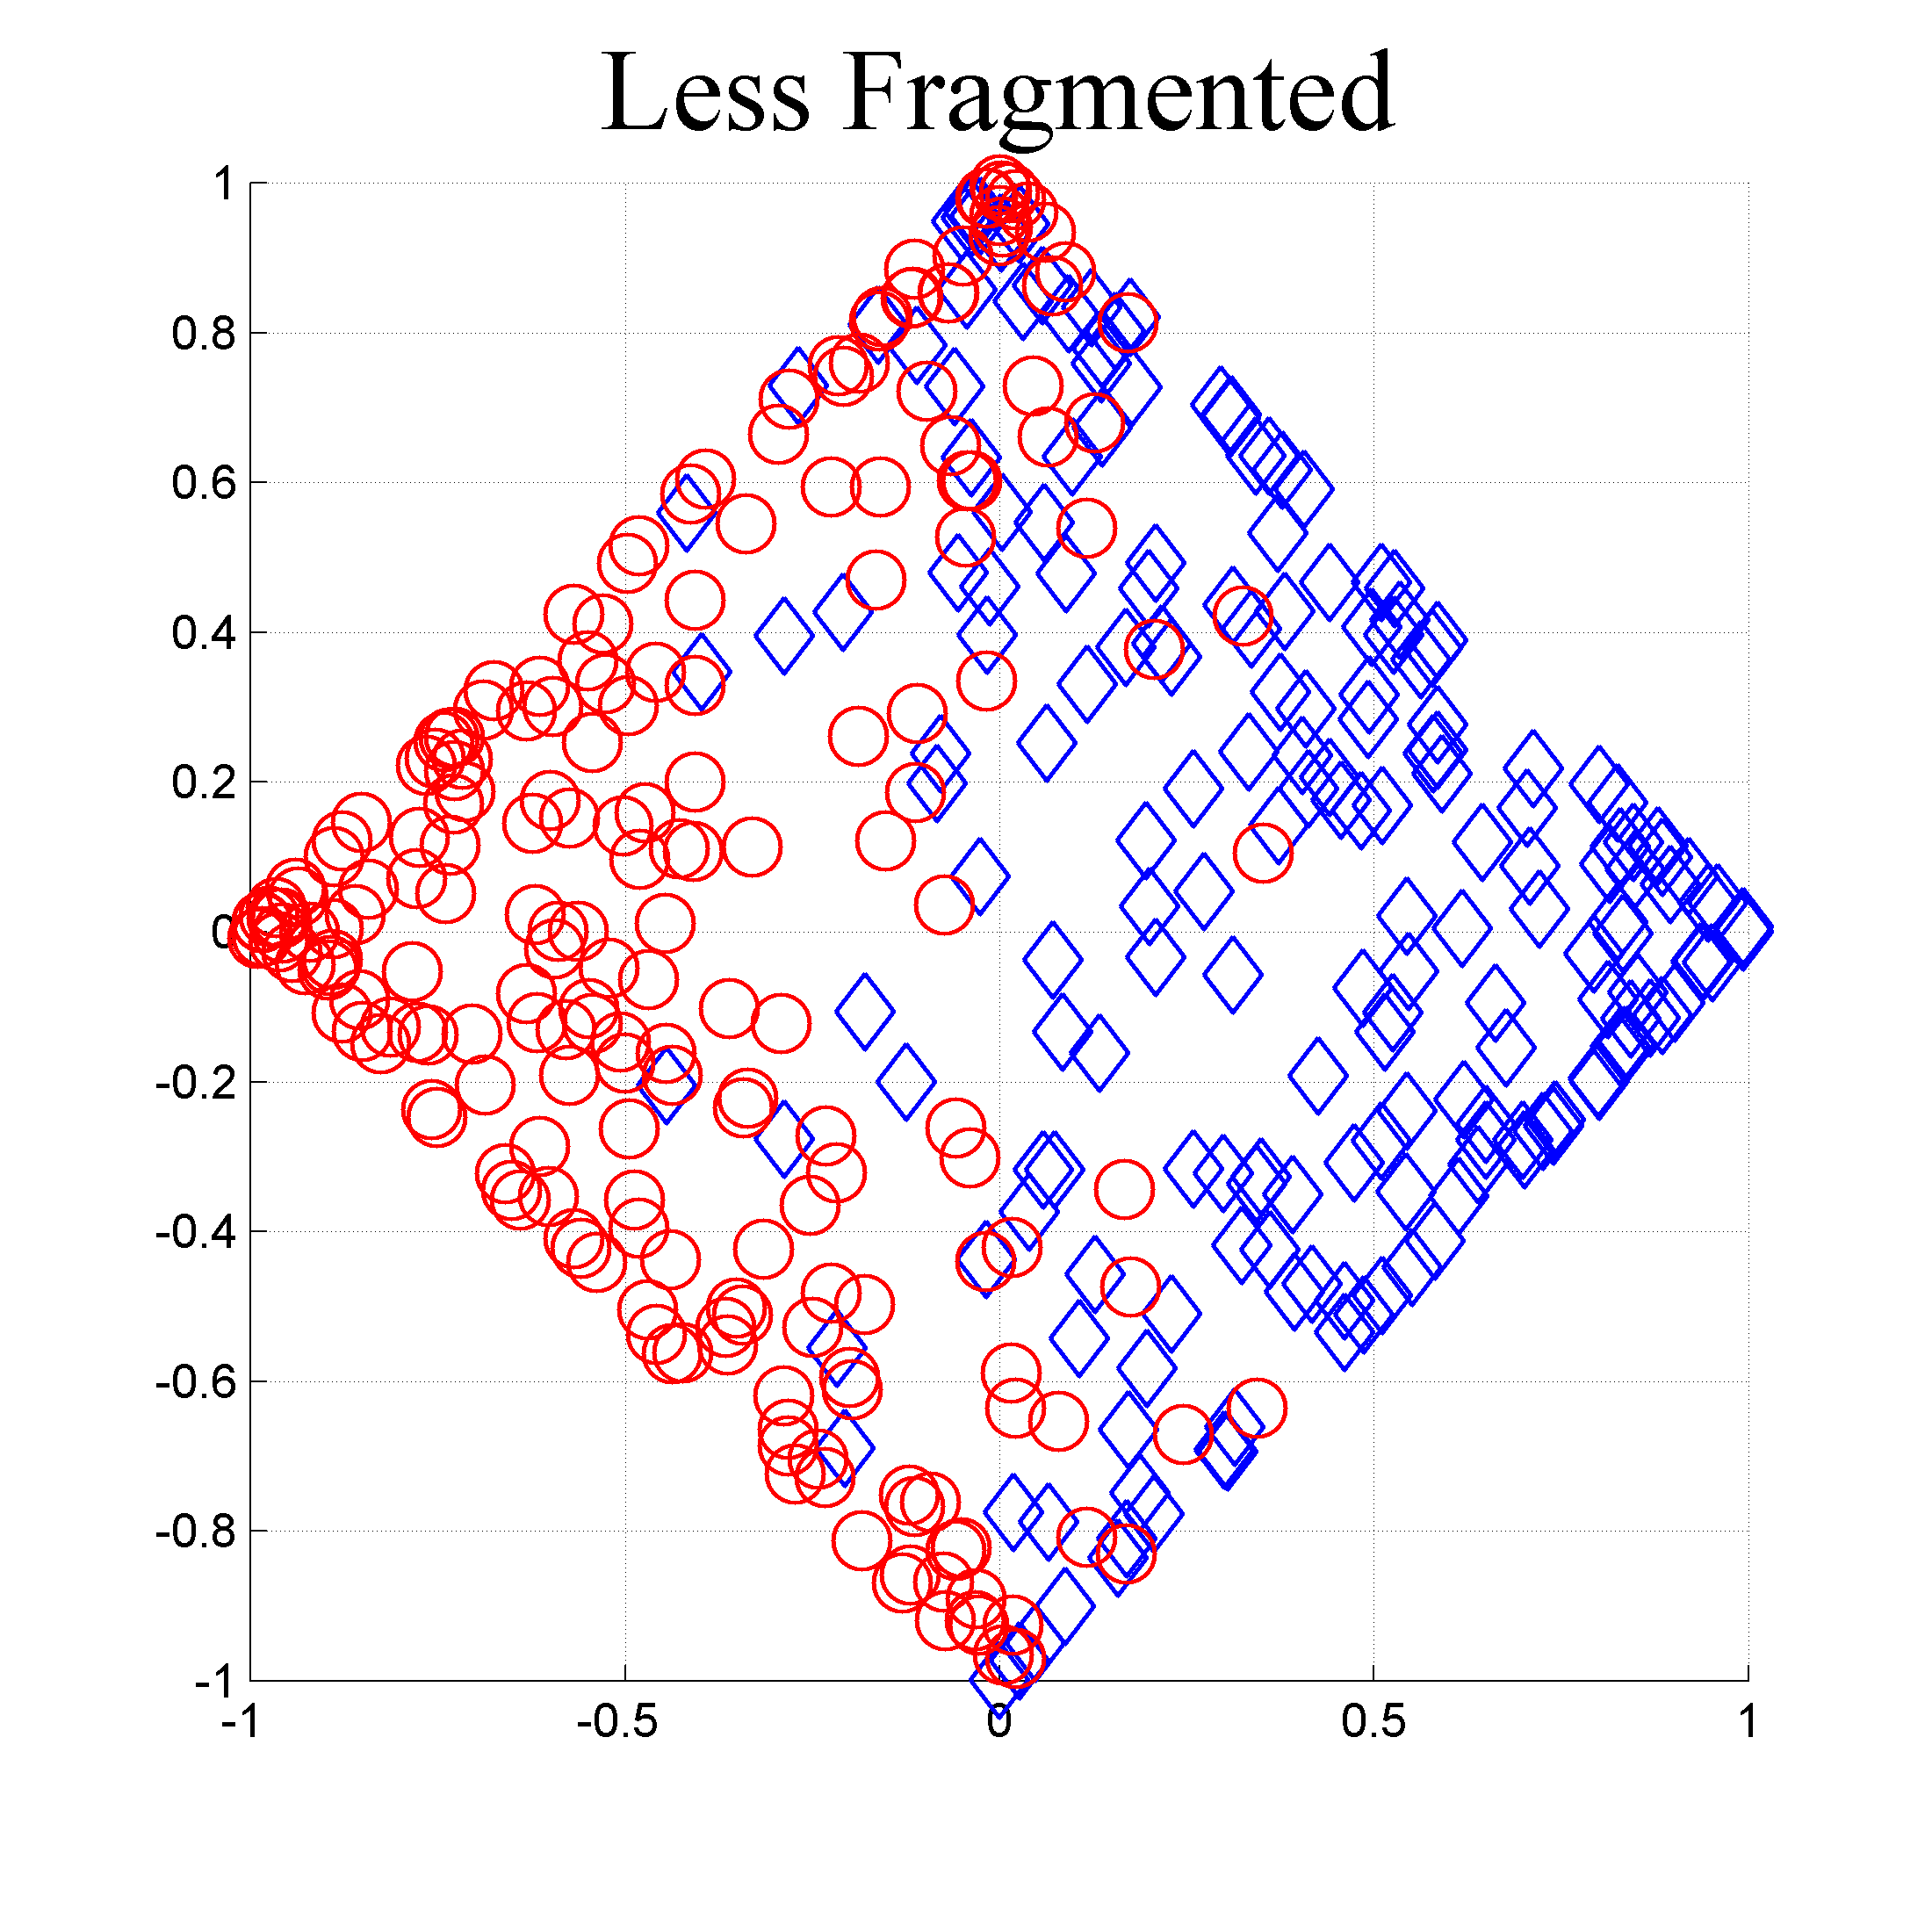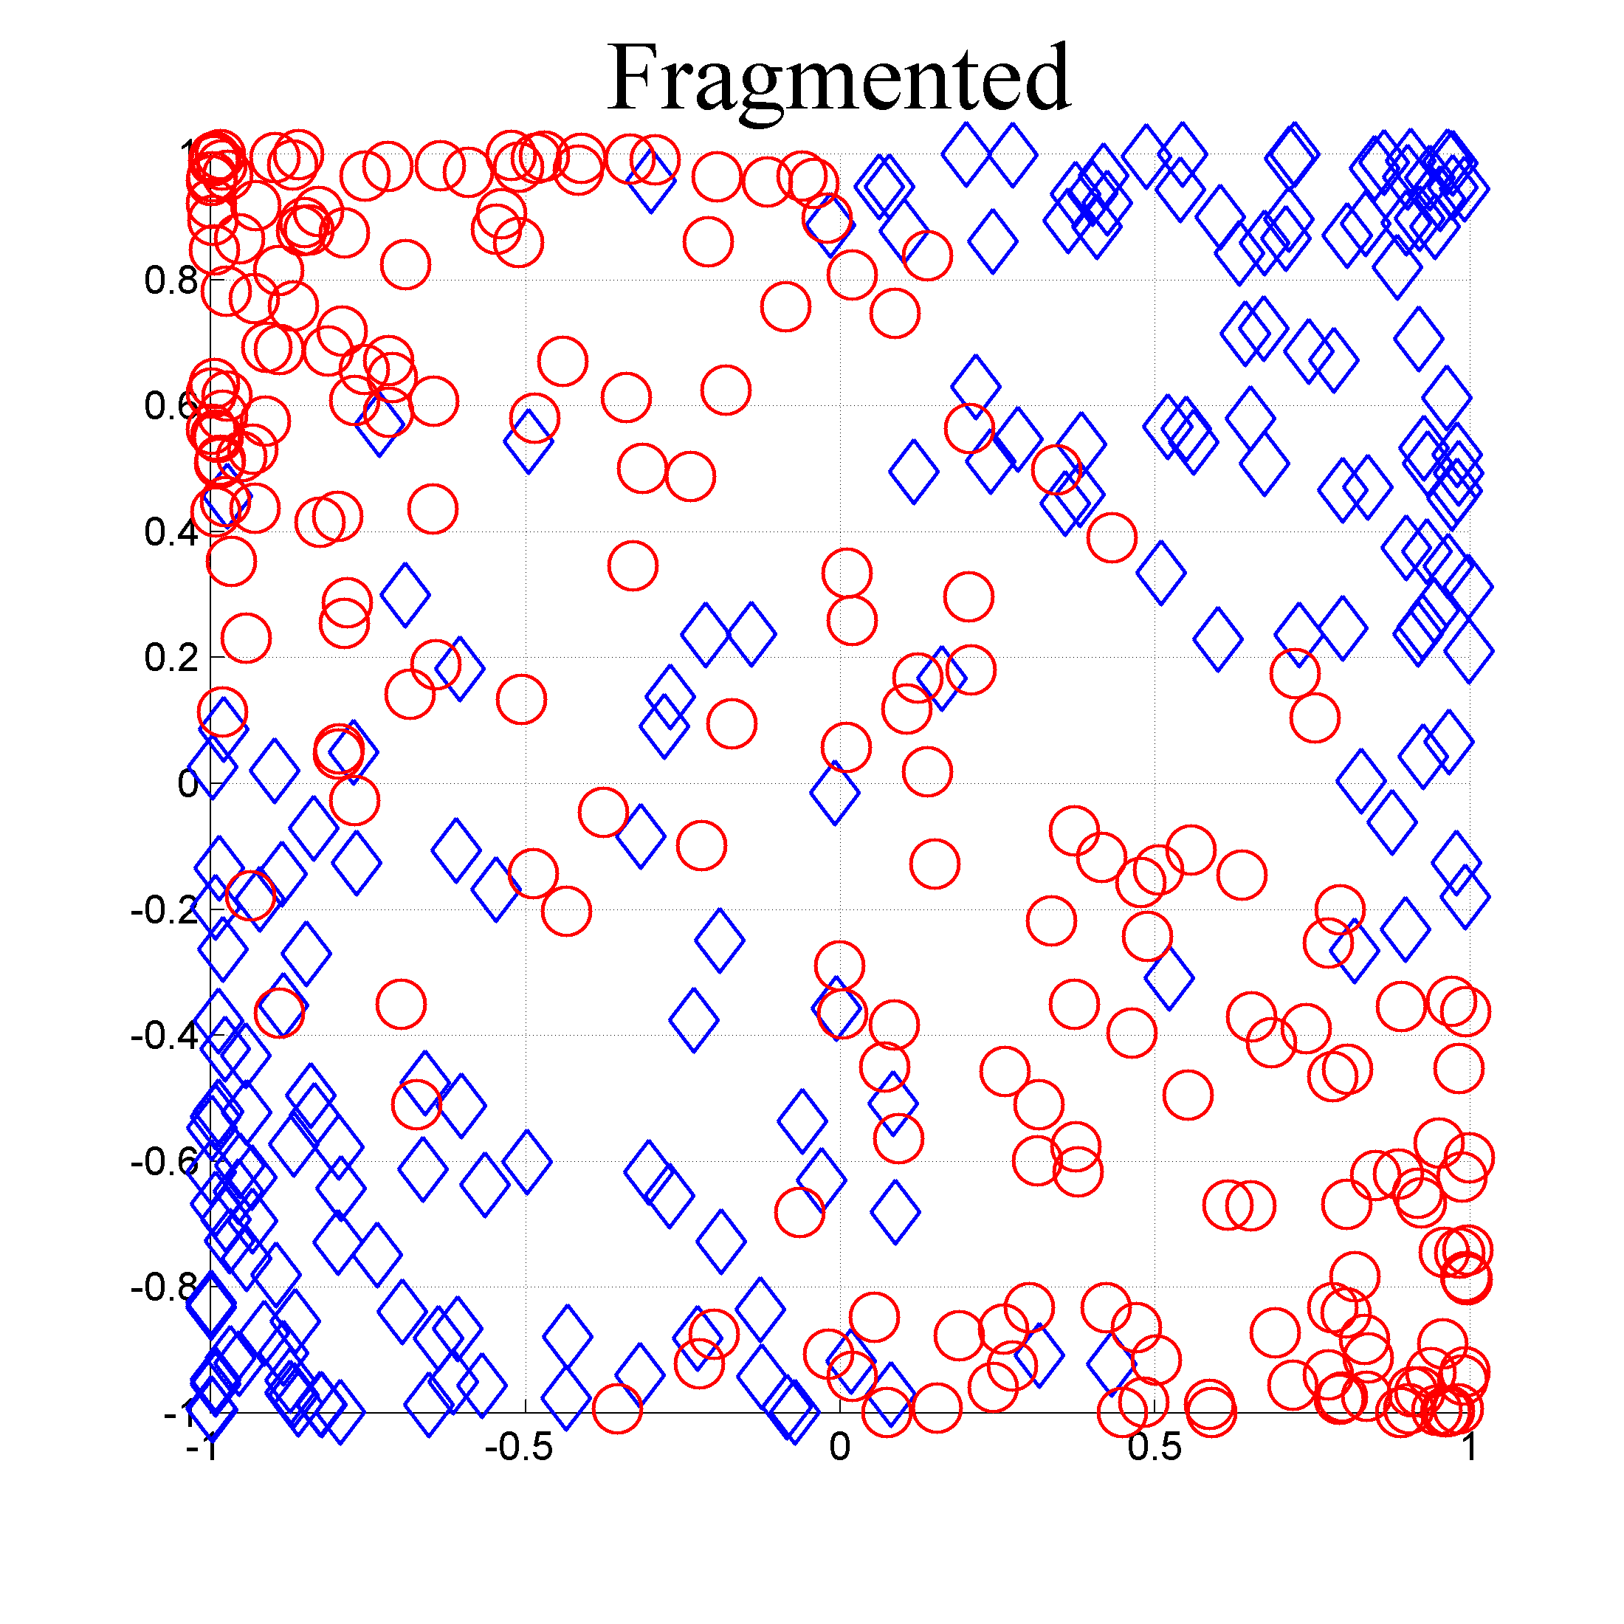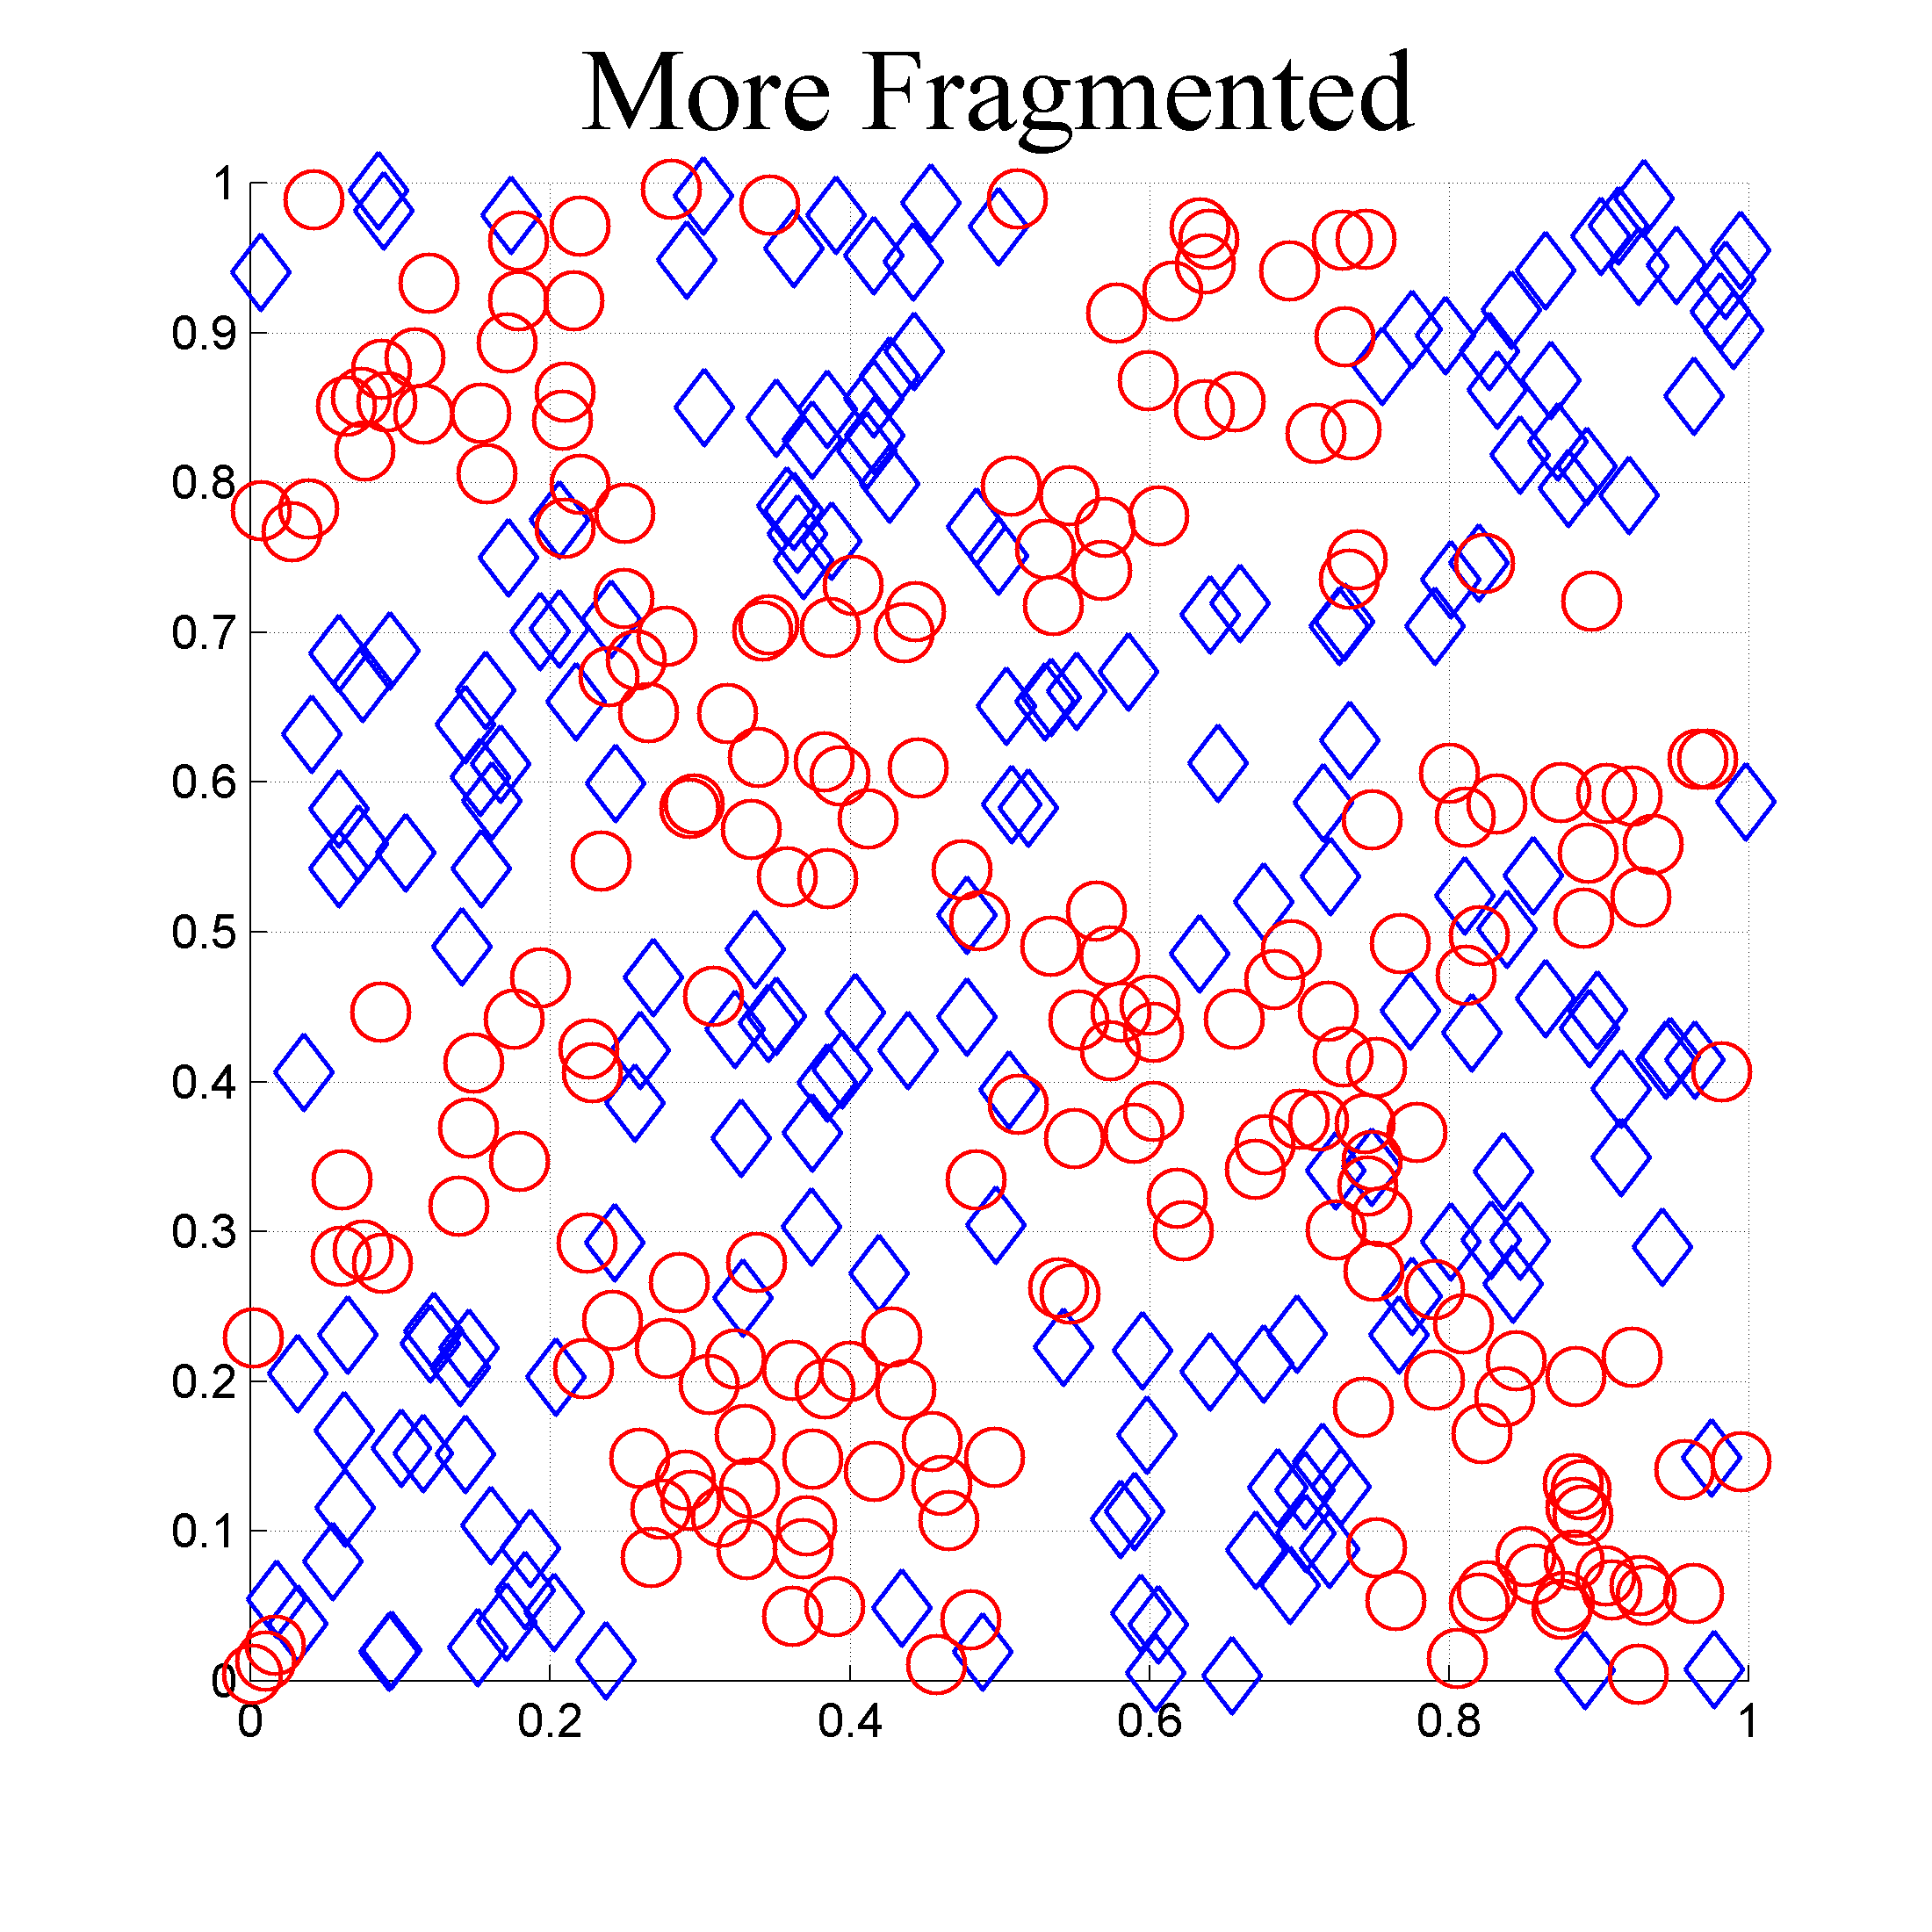

**A**

**B**

**C**

*s*1

*s*2

sin(*ks*2)

sin(*ks*1)

sin(*ks*1)sin(*ks*2)

cos(*ks*1) cos(*ks*2)

Figure 2. This figure illustrates the concept of category fragmentation while demonstrating how non-affine transformations can reduce fragmentation. **A.** The data (*s*1,*s*2) is very fragmented. **B.** A non-affine transform can be applied to reduce fragmentation. **C.** Another non-affine transformation reduces fragmentation even further. Since the vertical axis has no effect on category membership, it should be pruned from the feature space because irrelevant dimensions increase fragmentation.

The second and third scenarios (figs. 2B, 2C) show what happens when the axes of **x**-space are reformulated via some non-affine transform to reduce fragmentation. When fragmentation is nearly minimal, each category will have a small number of modes (preferably one) where category density falls regularly with distance from each mode. By minimizing fragmentation, we maximize the mutual adjacency of observations from the same category in each neighborhood of **x**-space. This means that our classifier’s relationship to **x**-space can be simple, and this reduces overfitting.

When a feature space contains features that are not relevant for classification, these extra dimensions will increase exposure to sampling noise, thereby diminishing classification performance. For example, in figure 2C the vertical axis should be pruned because it is irrelevant to category membership. An analyst should always take steps to remove irrelevant feature dimensions before fitting a classifier.

Later, we will discuss how to use a technique called cross-validation (e.g. Bishop 2006) to isolate the best set of features for classification. This technique essentially allows us to define a huge set of features, then prune irrelevant features to isolate the best subset. In almost every scenario, the best features are those which minimize fragmentation while minimizing irrelevant variance.

## What is a *common scenario*?

A *common scenario* is one where a skilled analyst is analyzing a realistic data set, and where the analyst has made reasonable attempts to design a feature space that minimizes fragmentation. In other words, the analyst has visualized the data, has transformed the variables, and has created features that appear to minimize fragmentation upon visual inspection. The analyst has also made reasonable attempts to eliminate features which seem irrelevant for classification. We don’t expect the analyst to be perfect. MoRPE is designed to pick up where the analyst left off.

## MoRPE

When compared to the Fisher Quadratic Discriminant (FQD), MoRPE is designed to handle a wider range of scenarios.

* For the **FQD,** we assume that each category is distributed as Gaussian in the feature space.
* For **MoRPE,** we assume that category fragmentation is relatively low, and that the feature space contains only information that might be relevant for classification.
  + In other words, we are assuming a *common scenario*.

The design of MoRPE flows naturally from the four assertions shown below.

1. A sensible way to estimate conditional probability is to **quantize** data over regions of the feature space.
2. If we know that the probability of category membership is monotonically related to some value *y* (which varies across the feature space), then we can use **monotonic regression** to estimate the conditional probability of category membership for any coordinate in the feature space.
3. We can utilize a **multivariate polynomial function** to define *y* in such a way that maximizes resistance to sampling noise.[4]
4. Since MoRPE’s estimates of conditional probability are guaranteed to be increasingly biased towards chance as the polynomial coefficients become increasingly suboptimal, then the polynomial coefficients can be optimized by **minimizing conditional entropy**.

These four assertions flow from basic assumptions about probabilistic classification and sampling noise. The remainder of this section will provide additional details about these assertions and how they are implemented.

A major difference between MoRPE and FQD is the way *y* is defined. [5]

* For the **FQD**, *y* is defined as a very specific function of **x** (see eq. 4).
* For **MoRPE**, *y* is defined as any function $g\left(x\right)$ intended to meet one requirement: The function $g\left(x\right)$ should be monotonic with $p\left(c | \text{x}\right)$ for all **x**.

**Key point**: MoRPE works by finding some $y→g\left(x\right)$ that is monotonic with $p\left(c | \text{x}\right)$ for all **x**.

For any given sample of data, there are an infinite number of possibilities for $g\left(x\right)$ that will work equally well, but MoRPE only needs to find one of them. This is a major reason for MoRPE’s success.

A different family of classifiers is also based on the assertion that *y* should be monotonic with $p\left(c | \text{x}\right)$ for all **x**: The sigmoid-based classifiers.[6] Unfortunately, these sigmoid-based classifiers require the analyst to make an assertion that is often difficult to justify: That *y* is related to $p\left(c | \text{x}\right)$ via a sigmoid function (which happens to be monotonic). This assertion is often unrealistic or unverifiable. As a result, sigmoid-based classifiers tend to produce imprecise or unreliable estimates of conditional probability.

### Quantization

MoRPE does not rely on sigmoid functions in any way. Instead, MoRPE defines a probability quantization function $\tilde{ρ}(c|\text{x})$ which serves as the preliminary estimate of $p\left(c | \text{x}\right)$. As figure 4 illustrates, the quantile boundaries are defined as iso-*y* contours across $\text{x}$-space.

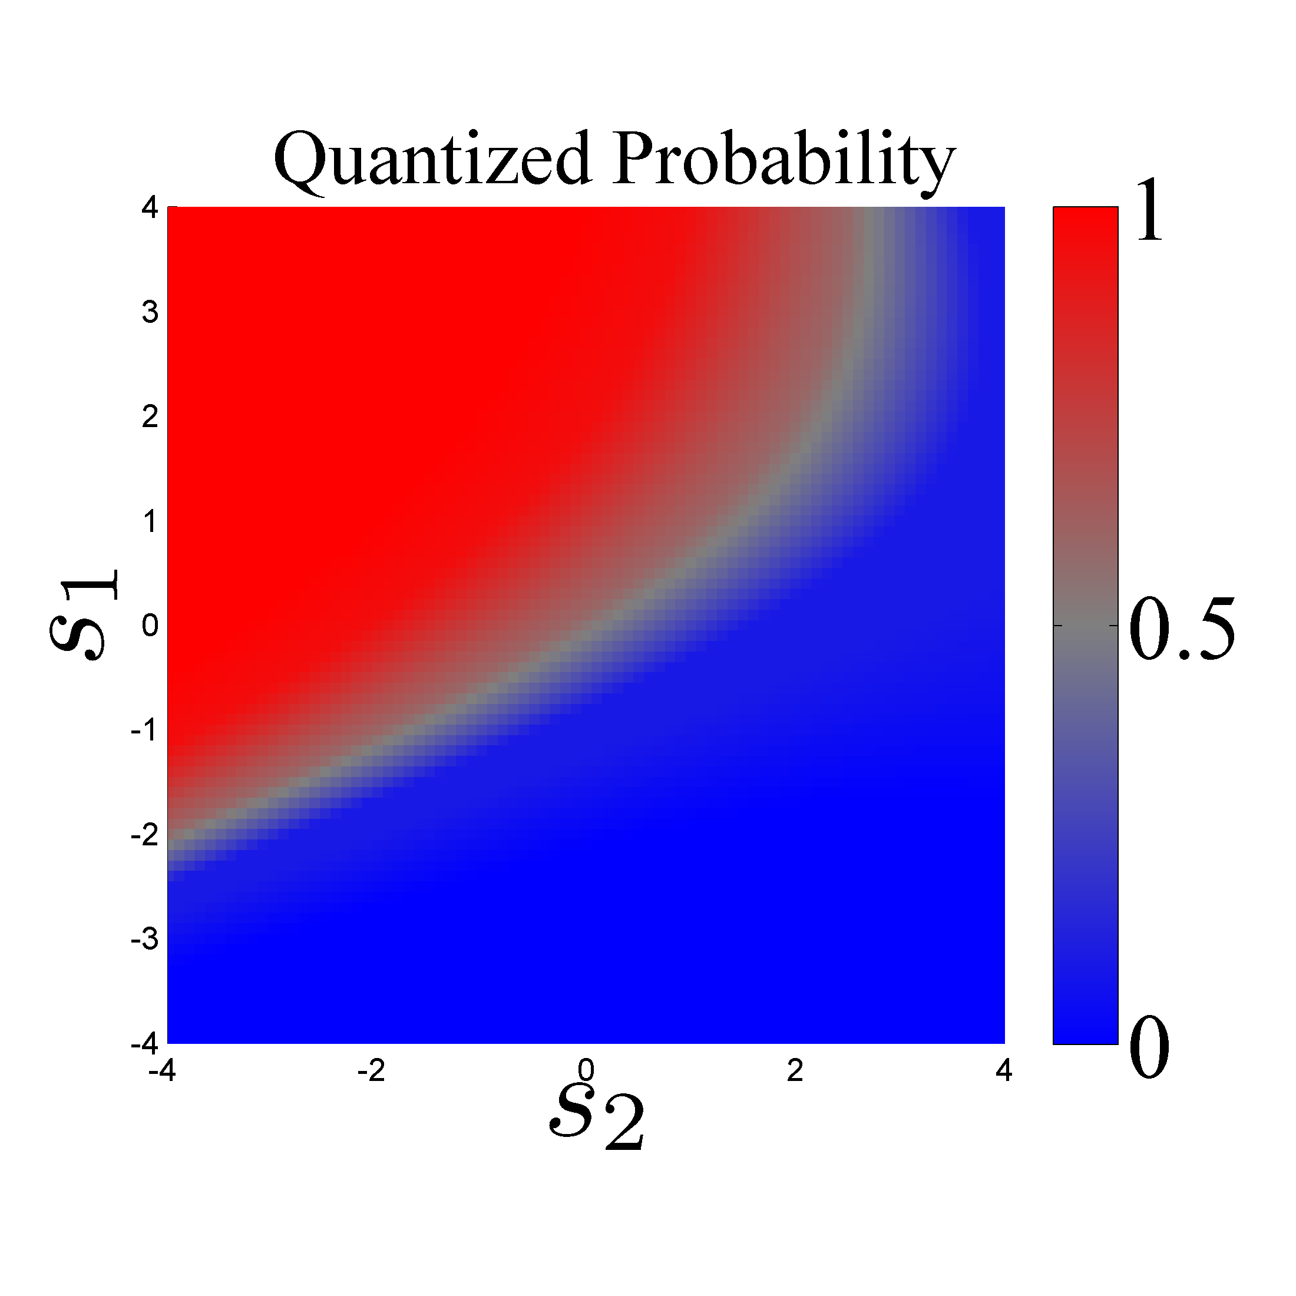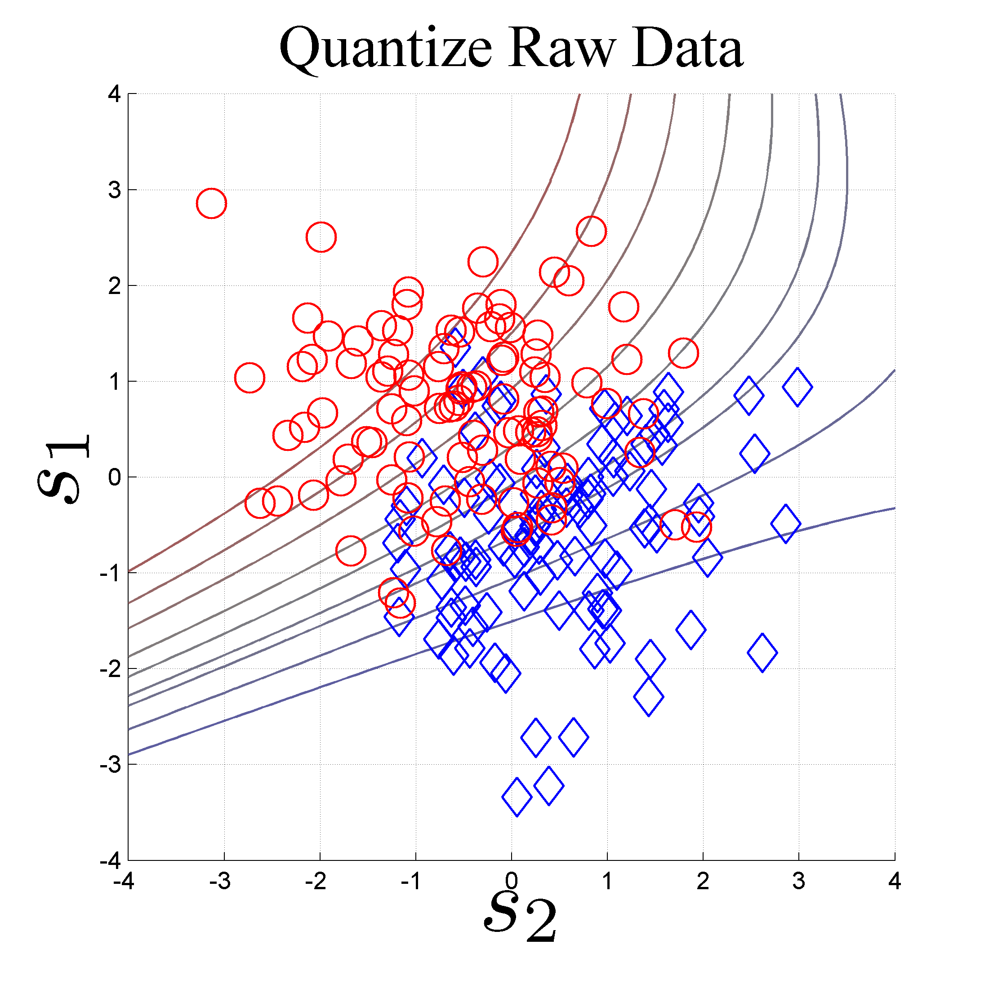

**A**

**B**

*x*1

*x*1

*x*2

*x*2

Figure 4. MoRPE uses quantization to estimate conditional probability as a function of **x**. **A.** Each contour represents a constant value of *y* in **x***­*-space. This is possible because *y* is always defined as some function of **x**. The contours are drawn so that gaps contain roughly equal numbers of data points. For more information, refer to the caption of figure 1A. **B.** After quantization has been performed, it is trivial to interpolate *y* for any location in **x**-space, thereby allowing us to compute the conditional probability as a function of **x**.

A quantile is a bin that holds a fixed number of data. In this case, each datum is a (*c* , *y*) value pair that is assigned to a quantile based on its *y*-value. We say the data is “quantized by *y*” because each quantile is associated with a span of *y*-values. This can be seen by inspecting figure 4A where quantile boundaries are illustrated as iso-*y* curves.

In figure 4A, category 1 is represented by red circles while category 2 is represented by blue diamonds. Suppose that one quantile contains 10 total samples consisting of 9 red and 1 blue. We can do simple arithmetic (9/10) to estimate that $p\left(1 | \text{x}\right)≈0.9$ for the region of **x** spanned by that quantile. This is roughly how MoRPE evaluates $\tilde{ρ}(c|\text{x})$, by quantizing **x** and then counting the proportion of samples from each category in each quantile.

The quantization procedure basically counts the number of samples from category *c* (denoted $n_{c,j}$) and the number of samples from other categories (denoted $n_{¬c,j}$) contained within any *j*-th quantile, then uses this information to define the function $\tilde{ρ}(c|\text{x})$. This function is also dependent on the observed base-rate or prior probability $p\left(c\right)$ for each category, a central bias parameter $b=1/2$, the total number of quantiles *Q*, and the quantile function $q\left(y\right)$. The behavior of $q\left(y\right)$ is easy to understand: As *y* approaches the lower limit of its observed range, the output of $q\left(y\right)$ approaches 0; when *y* is near the median of its observed range, the output of $q\left(y\right)$ approaches 0.5; and when *y* approaches the upper limit of its observed range, the output of $q\left(y\right)$ approaches 1.0. In the expression below, the $\left\lceil .\right\rceil$ brackets denote an integer ceiling operation which outputs the nearest integer equal or greater than bracket’s contents.

|  |  |
| --- | --- |
|  | (7) |

In the next section, we will see how MoRPE performs a *monotonic regression* of $\tilde{ρ}(c|\text{x})$ on *y* to calculate MoRPE’s final output as a precise estimate of conditional probability: $ρ(c|\text{x})$.

### Monotonic Regression

As we previously mentioned, it is well known that quantization (or binning) provides imperfect estimates of conditional probability. If a quantile contains 10 observations, and if exactly 9 observations originate from category 1, then we can say that $p≈0.9$ (approximately), but we cannot say that $p=0.9$ (exactly). This type of noise is well characterized by the binomial distribution (e.g. Cox 2006). There is also noise in the placement of quantile boundaries. We can group both types of noise into the term *quantization noise*, which is essentially a re-expression of sampling noise. This noise creates a major nuisance (as illustrated by the choppy shape of the blue curves in figure 5D, 5E, and 5F).

MoRPE is designed to resist this nuisance (as illustrated by the smooth shape of the red curves in figure 5D, 5E, and 5F). It suppresses most of the quantization noise by using a technique called monotonic regression. Specifically, MoRPE finds a function $ρ(c|\text{x})$ which is approximately equal to $\tilde{ρ}(c|\text{x})$ but which is otherwise required to be a monotonic function of *y*. More specifically: MoRPE performs a monotonic regression of $\tilde{ρ}(c|\text{x})$ on *y* to yield .

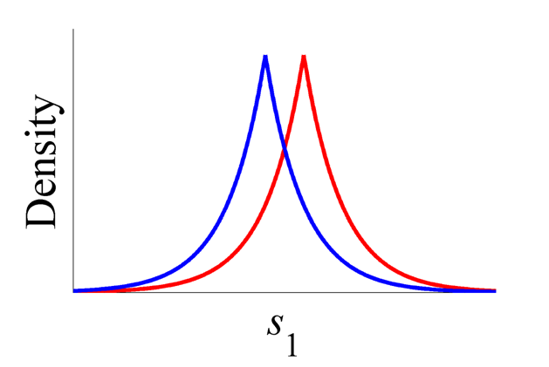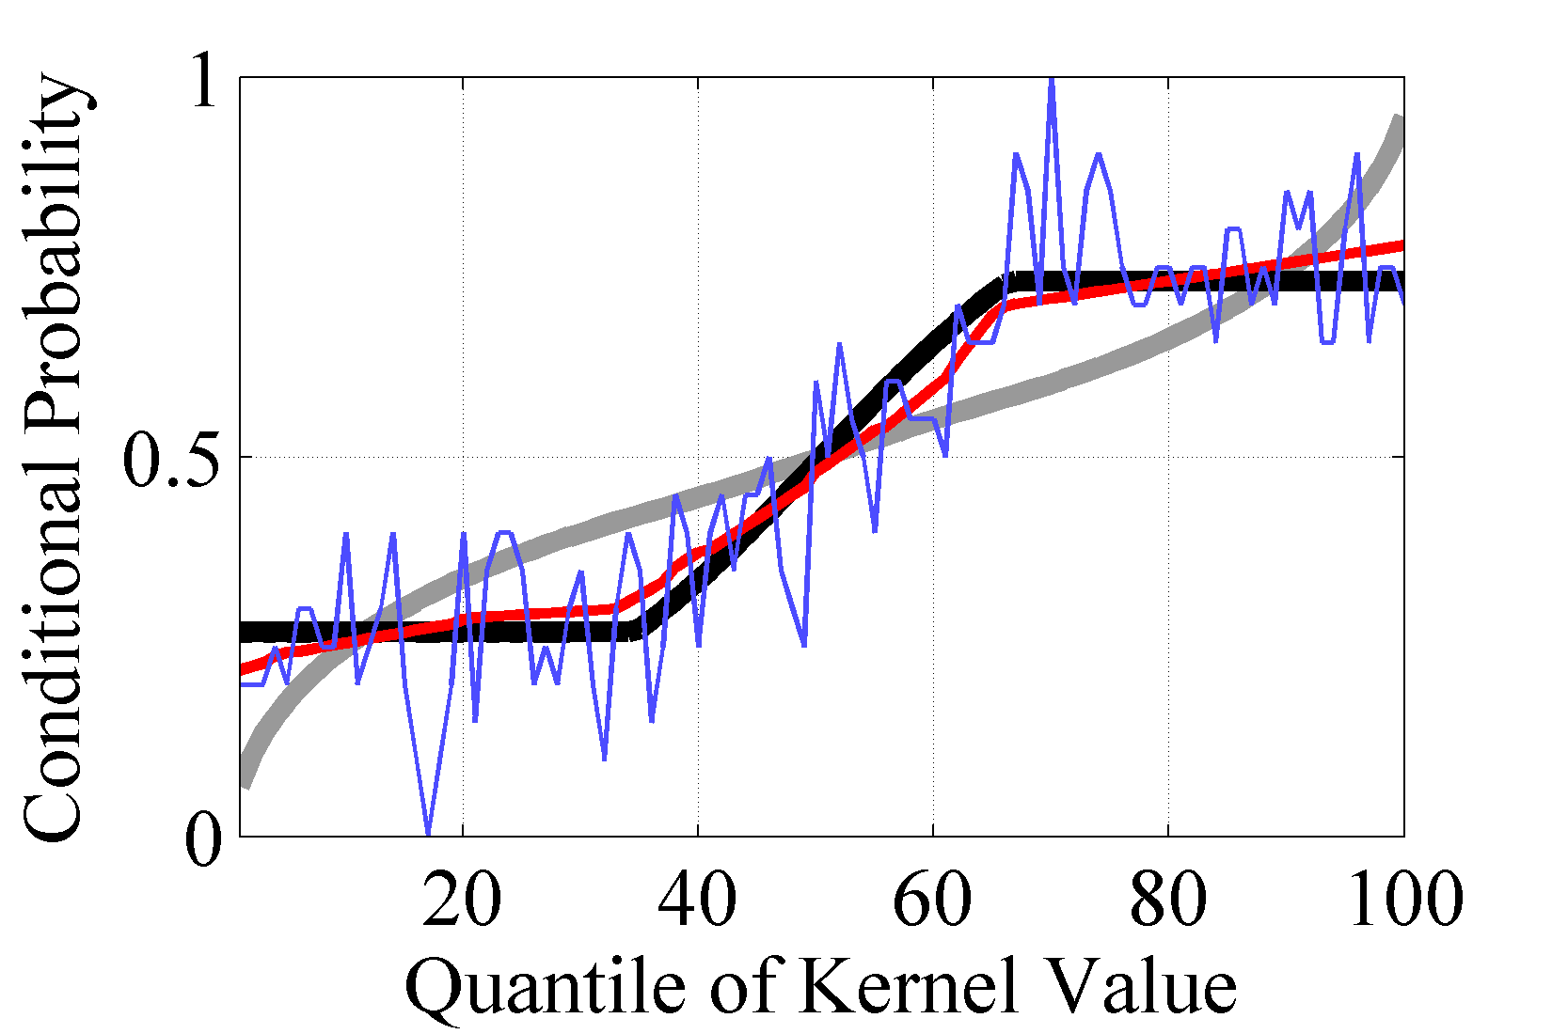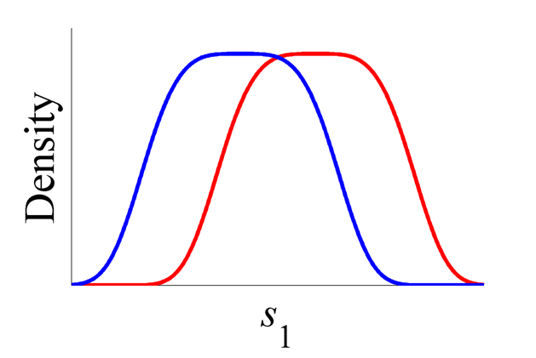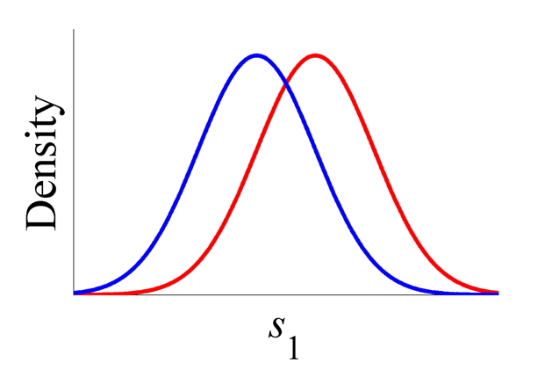

**A**

**D**

**C**

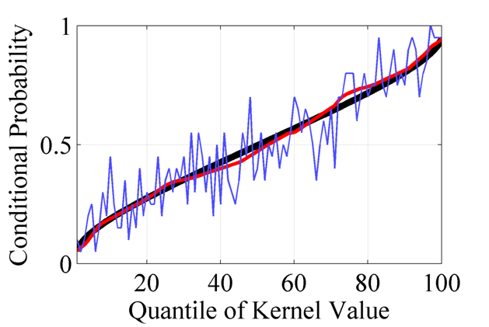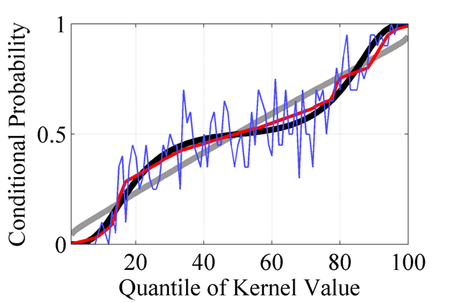

**E**

**F**

**B**

*x*1

*x*1

*x*1

Quantile Number

Figure 5. The rationale behind quantization and monotonic regression are illustrated in three scenarios. Each scenario simulates 1000 random samples from 2 category populations on a univariate axis $x_{1}$. The populations are generalized Gaussians with exponents 1 (figures **A** & **D**), 2 (figures **B** & **E**), and 4 (figures **C** & **F**). In figures **D**, **E**, and **F**, conditional probabilities (on the vertical axis) are shown as a function of the quantile number (on the horizontal axis) as predicted by the known truth (black) or the FQD (gray). The estimate of the model classifier $\tilde{ρ}(c|\text{x})$ from equation 7 is shown in blue. The model classifier $ρ(c|\text{x})$ is shown in red and was computed by monotonic regression of the blue curve.

Why does monotonic regression work so well? MoRPE knows whether $ρ(c|\text{x})$ should increase or decrease as a function of *y*. Any violations of this expectation are assumed to be quantization noise and are removed by enforcing monotonicity (via monotonic regression). In terms of noise reduction, this technique is extremely efficient and reliable. It is a major reason for MoRPE’s extreme precision and robustness.

### Polynomial Expansion

There is still one issue to overcome: How do we find some $g\left(x\right)$ that is monotonic with $p\left(c | \text{x}\right)$ for all **x**? For this we utilize a vector of free parameters **a**. From now on, we’ll denote the function as $g\left(x,a\right)$ to incorporate these parameters explicitly. A key point from earlier can be rephrased as follows.

**Key point**: MoRPE works by finding some $y→g\left(x,a\right)$ using some vector of parameters **a** such that $g\left(x,a\right)$ is monotonic with $p\left(c | \text{x}\right)$ for all **x**.

What family of functions should $g\left(x,a\right)$ be taken from? There is a clear reason to assert that $g\left(x,a\right)$ should be a multivariate polynomial function. We can control the classifier’s flexibility by setting the rank *R* of the polynomial expansion, and this affords a principled method for economizing the bias-variance tradeoff (discussed shortly).[7]

First, let’s define the multivariate polynomial function in terms of the polynomial expansion[8]. The polynomial expansion for $R≥1$ is denoted as a function $h_{R}\left(x\right)$ that inputs a vector $x$ and outputs a larger (expanded) vector **z**. Below are examples of this function for ranks of 1, 2, and 3 where we assume that the length of **x** is 3 so that $x={(x_{1} , x_{2} , x_{3})}^{T}$.

($R=1$) The *linear expansion* of ${(x_{1} , x_{2} , x_{3})}^{T}$ is shown below.

|  |  |
| --- | --- |
| $$z→h_{1}\left(x\right)≡ {(1 ,x_{1} ,x_{2} , x_{3})}^{T}$$ | (8) |

($R=2$) The *quadratic expansion* of ${(x_{1} , x_{2} , x_{3})}^{T}$ is shown below.

|  |  |
| --- | --- |
| $$z→h_{2}\left(x\right)≡ {(1 ,x_{1} ,x_{2} , x_{3} ,{ x}_{1}^{2} ,{ x}_{2}^{2} , x_{3}^{2} ,x_{1}x_{2} ,x_{1}x_{3} , x_{2}x_{3})}^{T}$$ | (9) |

($R=3$) The *cubic expansion* of ${(x_{1} , x_{2} , x_{3})}^{T}$ is shown below.

|  |  |
| --- | --- |
| $$z→h_{3}\left(x\right)≡ {\left(\begin{aligned}1 ,x_{1} ,x_{2} , x_{3} ,{ x}_{1}^{2} ,{ x}_{2}^{2} , x_{3}^{2} ,x_{1}x_{2} ,x_{1}x_{3} , x_{2}x_{3}, \\ { x}_{1}^{3} ,{ x}_{2}^{3} , x_{3}^{3},{ x}_{1}^{2}x_{2},{ x}_{1}^{2}x_{3} ,{ x}_{2}^{2}x_{1},{ x}_{2}^{2}x_{3} , x_{3}^{2}x_{1}, x_{3}^{2}x_{2}, x_{1}x_{2}x_{3}\end{aligned}\right)}^{T}$$ | (10) |

We say that the feature space’s dimensionality is *D*, so *D* is equal to the length of **x**. In general, for a polynomial expansion of some rank *R* and some dimensionality *D*, the length of **z** is exactly *H*.[9]

|  |  |
| --- | --- |
|  | (11) |

Now this allows us to define $g\left(x,a\right)$ for a given *R* as follows. Notice how this makes *y* into a linear function of **z**, but potentially a nonlinear function of **x**.

|  |  |
| --- | --- |
| $$y→g\left(x,a\right)=a∙{h_{R}\left(x\right)}^{T}=a∙z^{T}$$ | (12) |

There are two main reasons why $g\left(x,a\right)$ should be from the multivariate polynomial family. First, it buys us invariance to affine transformations of **x**. Any affine transformation of **x** is implicitly handled during the optimization of free parameters **a**.

Second, if we revisit the FQD, we notice from eq. 4 that a polynomial function where $R=2$ is optimal for Gaussian categories. In other words, eq. 4 is a specific function of the family defined by eq. 12 where $R=2$. So if our categories happen to be Gaussian, MoRPE is expected to behave like the FQD.

Now let’s take a step back and ask: Why is the FQD is a multivariate polynomial of rank 2? It is because Gaussian distributions are defined using only second order moments (covariances) and first order moments (means). These statistical moments describe the shape of a multivariate probability distribution.[10]

In fact, we can think of multivariate Gaussians as a family of distributions based on the polynomial of rank 2. We can imagine a larger family of distributions based on polynomials of higher rank. Such distributions would be like Gaussians, but with a wider flexibility of shape. If we choose to define a probability distribution by using a multivariate polynomial of rank *R*, we get to explicitly define the non-default behavior for any statistical moments up to rank *R*. Statistically, the lowest order moments (means) are the most resistant to sampling noise. The second order moments (covariances) are the next most resistant to sampling noise. As the order of moments increases, their resistance to sampling noise diminishes (Press et al. 2002).

In appendix A, I prove that if the probability distributions were specified as polynomials up to rank *R*, then an optimal classifier can be specified as a closed form expression that incorporates another *R*-th order polynomial. Therefore, by choosing $g\left(x,a\right)$ to be a *R*-th order polynomial expansion, we are economically managing the bias-variance tradeoff. It gives us a parameter space that is not contaminated by any moments higher than *R*. In other words, we get the highest flexibility per parameter when $R=1$, a bit less when $R=2$, still less when $R=3$, and so on.

Later I describe how a cross-validation procedure can be used to find the best value of *R* for any given data set.

### Conditional Entropy Minimization (CEM)

In order to be explicit about MoRPE’s usage of parameters **a**, we can rewrite $ρ(c|\text{x})$ as $ρ(c|x,a)$. So far, I have described how MoRPE evaluates the function $ρ(c|x,a)$, but I have not yet described how to optimize the parameters **a**.

Generally speaking, the goal is to optimize **a** so that MoRPE’s output $ρ(c|x,a)$ matches the real probability $p(c|x)$ as well as possible. Like any optimization problem, we have the freedom to specify an *optimization objective* (i.e. the function that we are seeking to maximize or minimize). For reasons given shortly, I assert that Conditional Entropy Minimization (CEM) is the most appropriate objective.

The conditional entropy is specified in Bishop (2006 §1.6). Here we specify the conditional entropy as ${-log}_{M}λ$ where *M* is the number of categories. Conditional entropy is a function of each *i*-th datum where the sample contains *N* data.

|  |  |
| --- | --- |
|  | (13) |

The classifier approaches omniscience as $-\log_{M}λ→0$, is random when $-\log_{M}λ=1$, and is worse than random for all .[11] We treat the sample as a particle filter and set $p(c_{i},x_{i})=1/N$ for all *i*. As a result, we define conditional entropy using a simpler expression.

|  |  |
| --- | --- |
|  | (14) |

In this case, conditional entropy minimization is equivalent to maximizing $λ$: The geometric mean of $ρ(c_{i}|x_{i},a)$ assigned to the correct category across the training sample. Performance approaches omniscience as $λ→1$ and worsens as .

|  |  |
| --- | --- |
|  | (15) |

MoRPE optimizes the parameters **a** to minimize $-\log_{M}λ$ which is equivalent to maximizing $λ$. The best possible classification performance is achieved as $λ→1$, and this can only be achieved by meeting both of the following conditions: The classifier must be (1) perfectly accurate and (2) perfectly confident[12] for all *i*.

The reason for using CEM is to increase MoRPE’s resistance to sampling noise. The goal of CEM is to maximize $λ$ which is defined as the product of $ρ(.)$ values assigned to the correct category (see eq. 15). The key is that $ρ(.)$ tends toward extreme values (approaching 0 and 1) as **a** approaches its optima.[13] In addition, $λ$ becomes increasingly sensitive as $ρ(.)$ becomes increasingly extreme.[14] As a result, MoRPE is most strongly rewarded (or punished) whenever it asserts extreme values of $ρ(.)$, a situation that corresponds to relatively weak sampling noise. In contrast, sampling noise is stronger when values of $ρ(.)$ are non-extreme.[15] The bottom line is that CEM optimizes MoRPE by considering accuracy and confidence.

CEM imposes the following characteristics on MoRPE:

* MoRPE is rewarded for obtaining high classification accuracy.
* When MoRPE guesses correctly, it is rewarded for asserting high confidence.
* When MoRPE guesses incorrectly, it is rewarded for asserting low confidence.
* When MoRPE guesses incorrectly while asserting high confidence, a very strong penalty is imposed, so MoRPE tends to avoid making such errors.[16]

## Extending MoRPE

So far, I have defined MoRPE in the context of a standard 2-category classification problem. MoRPE can be extended to accommodate a wider variety of contexts, two of which are discussed here. First I consider the case where we want to specify equal prior probabilities (or base-rates) of each category, irrespective of the base-rates observed in the sample. Second I consider the multi-category problem (for more than 2 categories).

### Enforcing Equal Base-Rates (a.k.a. Equal Priors)

It is often the case that a training sample will contain unequal representation from each category, yet the analyst wants to treat the situation as though each category has an equal prior probability of appearing. In a case like this, each category should have equal influence over the parameters **a**.

MoRPE can be adjusted to enforce equal priors (or base-rates) by computing a weight for each category $\{w_{1},…,w_{M}\}$. These weights are determined from the total number of data sampled from each category $\{N_{1},…,N_{M}\}$. The weight for some category *c* is computed as follows.

|  |  |
| --- | --- |
| $$w_{c}=\frac{1}{MN_{c}}\sum_{i=1}^{M}{N_{i}}$$ | (16) |

I replace eq. 7 with the following.

|  |  |
| --- | --- |
|  | (17) |

I replace eq. 14 with the following.

|  |  |
| --- | --- |
|  | (18) |

I replace eq. 15 with the following.

|  |  |
| --- | --- |
|  | (19) |

When MoRPE is altered by the preceding steps (eq. 16-19), it will always behave as if each category has equal priors or base-rates. This is useful for applications where one category is extremely rare. This allows the rare category to have equal influence over the solution, and this may be important when the rare category has high utility.

### Multiple Categories

The ability to precisely estimate an optimal classifier for the 2-category problem leads to another important ability: The ability to handle problems with multiple categories in a natural way. Other classifiers tend to employ special tricks for handling multiple categories, but these tricks require the analyst to make additional assumptions that are difficult to justify. MoRPE is different because it simply leverages its remarkable precision for 2-category problems.

There are many possible ways of leveraging MoRPE from a 2-category classifier into an *M*-category classifier. Here I describe the most simple approach which I believe is typically the best approach.

**Key Point**: Since MoRPE is capable of estimating $p\left(c | \text{x}\right)$ as $ρ\left(c|\text{x},a\right)$ with remarkable precision for the 2-category problem, the *M*-category problem can be solved implicitly by computing solutions to *M* distinct 2-category problems.

In the case of $M=2$ where $c∈\{1,2\}$, we use a single multivariate polynomial function to estimate a single probability, say $p\left(1 | \text{x}\right)$. The second probability is given to us for free because we know that $p\left(2 | \text{x}\right)=1-p\left(1 | \text{x}\right).$

In the case of $M>2$ where $c∈\{1,…,M\}$, we are required to use *M* distinct polynomial functions. In fact, I actually implement MoRPE as a collection of *M* distinct 2-category classifiers, then I combine the results to arrive at a single *M*-category classifier. The remainder of this section adopts a special notation where the 2-category classifiers are noted with a subscript $ρ_{c}\left(c|\text{x},a_{c}\right)$ while the resultant *M*-category classifier has no subscript $ρ(c|x,A)$ where $A=\left(\begin{matrix}a_{1} & … & a_{M}\end{matrix}\right)$.

Each $c$–th 2-category classifier $ρ_{c}\left(c|\text{x},a_{c}\right)$ serves the purpose of separating category $c$ from the aggregate of all other categories. These *M* distinct 2-category classifiers can then be combined into a single *M*-category classifier $ρ(c|x,A)$ using the following equation.

|  |  |
| --- | --- |
|  | (20) |

Upon routine inspection, we notice that the previous equation is not biased towards any particular category. The previous equation also guarantees that the following equation is always satisfied.

|  |  |
| --- | --- |
|  | (21) |

During optimization, the *M*-distinct 2-category classifiers are first optimized separately (as if taken from separate 2-category problems). Next the parameters are optimized together to generate a holistic *M*-category solution to the *M*-category problem. Just as before, the optimization objective is to minimize conditional entropy. The definitions of conditional entropy, provided earlier, are all compatible with the notion of multiple categories; but they should be altered to incorporate the quantity defined in eq. 20.

I replace equation 14 with the following.

|  |  |
| --- | --- |
|  | (22) |
|  |  |

I replace eq. 18 with the following.

|  |  |
| --- | --- |
|  | (23) |

## Discussion

MoRPE is a powerful new method for approximating an optimal classifier with remarkable precision. Its design flows from basic assumptions about the fundamental nuisance of sampling noise. Like any method, MoRPE has specific limitations that determine how it should be applied.

## Limitations of MoRPE

MoRPE has three primary limitations. First, like all comparable methods, this method approximates the optimal classifier for a given formulation of **x**, but not all possible formulations of **x**. When a user applies the method, they have freedom to formulate **x** however they choose. In many (perhaps all) applications, **x** is a simple representation of a more complex signal. In such cases, there are an infinite number of ways to formulate **x**. This potentially limits the generality of results because any single result is dependent upon an arbitrary formulation of **x**. This is a real limitation, but it can be partially overcome by applying a *guess and check procedure*. In such a procedure, the analyst can guess a specific formulation of **x**, then check its level of performance. Obviously, the procedure’s goal is to find the formulation of **x** that leads to the best possible performance, and this is usually measured by the standard technique of cross-validation (e.g. Hastie et al. 2008 §7.10). With enough skillful guesswork, the guess and check procedure should uncover a nearly optimal formulation of **x**.

Second, as previously discussed, the new method guarantees that for a given data set, classifier performance is equivalent for all possible affine transformations on **x**. However, arbitrary non-affine transformations can still influence classifier performance. Therefore it may be important to consider the effects of reformulating **x** via arbitrary non-affine transformations. This consideration can be built into the guess and check procedure. As previously discussed, a successful non-affine transformation of **x** should minimize category fragmentation (in **x**-space). The extent to which this requirement has been met is usually (but not always) revealed during visual inspection of the data as projected into 1D and 2D subspaces (in **x**-space). When compared with existing methods (e.g. FQD, logistic regression, ridge regression, SVM, and RVM), the new method is most resistant to the nuisance of arbitrary non-affine transformations.

Third, for the new method, the training of free parameters is not a convex optimization problem. Convex optimization problems are typically preferred because convexity makes it easy to find optimal parameter values. While MoRPE is not optimized in a convex way, in common scenarios MoRPE’s objective function is well behaved. Specifically, the surface of $λ$ has relatively smooth and minor ripples across **a**, not major discontinuities. This means that in common scenarios, it should be possible to employ moderate computational brute-force to reveal a solution that is nearly optimal. However, since the optimal solution can be elusive, it is advisable to employ standard techniques like simulated annealing (e.g. Press et al. 2002 §10.9), adaptive step-size control, and convergence criteria (e.g. Press et al. 2002 §15.5) during parameter optimization.

Overall, MoRPE’s three primary limitations are actually quite unrestrictive when compared to the limitations of other popular methods. MoRPE is based on a single assumption which is relatively unrestrictive. This assumption is that category fragmentation is low. Even when this assumption has not been met, MoRPE tends to produce non-extreme estimates of conditional probability.

## Parameter Optimization

If there is any downside to employing MoRPE, it is the requirement for moderate brute-force during parameter optimization. However, since the optimization surface is only expected to have minor deviations from convexity, the computational requirements tend to be reasonable (as previously discussed). Moreover, after the parameters have been optimized, the classifier can be evaluated very quickly.

Some other methods (e.g. SVM) can be trained with a convex optimization problem, but this does not mean that such methods are superior to the new method introduced here. In order for these other methods to achieve convexity, they must introduce additional complications: (1) A suboptimal objective function is usually required and/or (2) if memory resources are limited, the number of training samples must be strongly limited in order to solve a convex *dual problem* (defined in Dantzig 1963, p. 134). Therefore, the new method actually has two advantages over the existing convex methods: (1) The user can minimize conditional entropy and (2) training can be based on a much larger sample size, thus providing more resistance against sampling noise.

## Implementation

MoRPE was implemented as a single-threaded CPU (*Central* Processing Unit) application which was programmed in the languages of C and Matlab. The next logical step is to create a version of MoRPE that can be trained more quickly. To achieve this goal, I plan to implement MoRPE on a GPU (*Graphics* Processing Unit) architecture and eventually a cluster of GPU servers. The algorithm is primarily consumed by two activities: (1) A large matrix multiplication and (2) a monotonic regression which is basically a sorting algorithm (e.g. MergeSort, QuickSort) that sorts *y*-values for the training sample. Typically (during optimization), this list of *y*-values is mostly sorted before the sorting algorithm is applied. The first activity (matrix multiplication) is highly amenable to GPU architecture. The second activity (sorting) is moderately amenable to GPU architecture when the list is mostly sorted already.

## Perceptual Systems: A Special Application

While MoRPE has many possible applications, it has already been applied to investigate the design of a perceptual system that segments leaves from foliage-rich scenes. This section summarizes that work which was previously reported by Ing (2010). Specifically, Ing (2010) studied the three classification tasks illustrated in figure 6 by collecting a ground-truth sample (a collection of hand-segmented images). MoRPE was then applied to the training sample so that optimal classifiers could be approximated. For all three problems, nearly optimal feature sets were isolated by using the method of *guess and check with cross-validation* (as previously discussed in this paper).

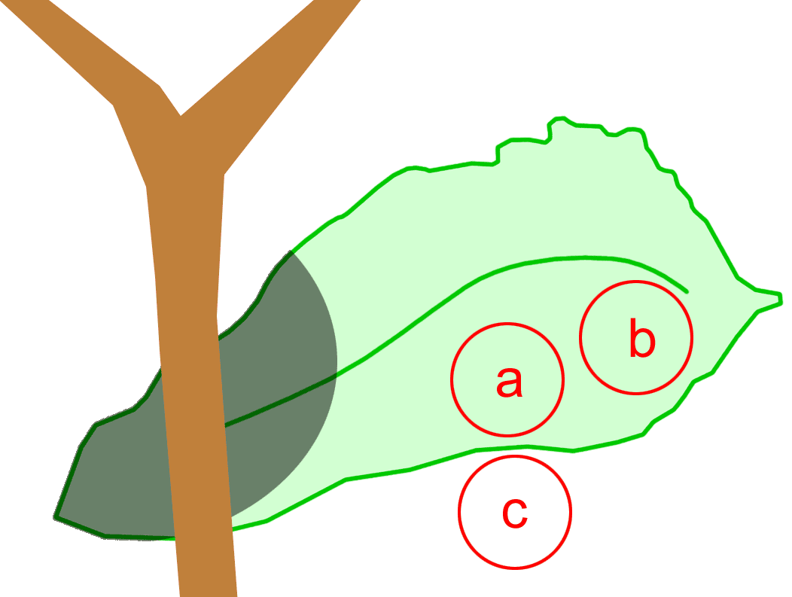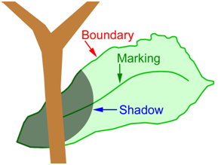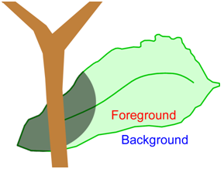

**A**

**B**

**C**

Figure 6. For the natural task of leaf identification, three possible natural subtasks are illustrated. **A.** Three circular image patches demonstrate how a patch pair classifier can classify pair (a,b) as *same* and pair (a,c) as *different*. **B.** A classifier can assign foreground-background polarity for an accurately detected boundary. **C.** A classifier can identify contours as *boundary*, *marking*, or *shadow*.

Figures 7 and 8 illustrate how MoRPE was trained to the sample of data for the *patch pair classification problem* illustrated in figure 6A. Both figures show ground-truth distributions for six features. MoRPE was also trained with respect to the combined set of 12 features, some of which were dropped because they introduced unwanted fragmentation (which introduced unwanted sampling noise).

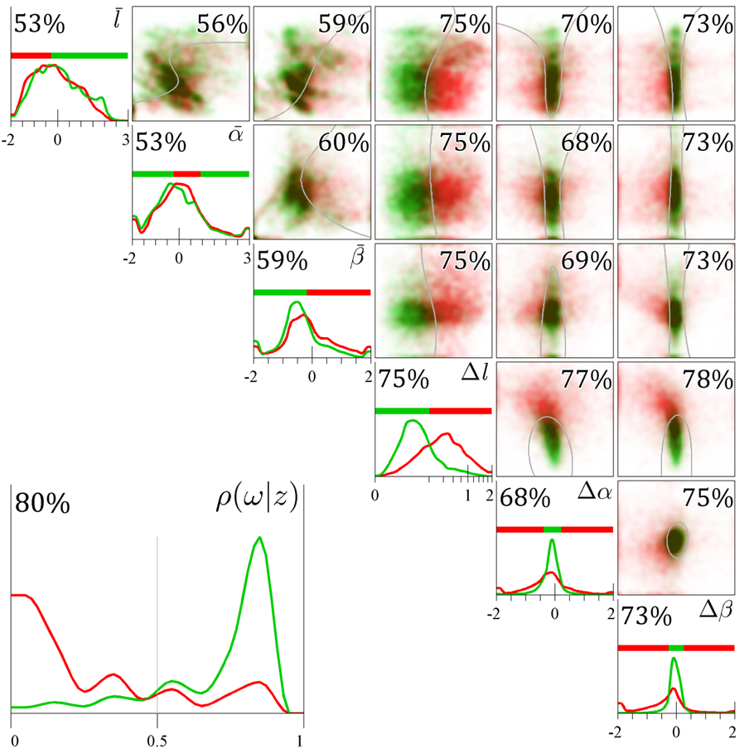

*ρ*( *c* | *y* )

Figure 7. Ground-truth distributions for category *same* (green) and *different* (red) are illustrated. Six properties are shown and the separation between patch centers is 1/4 leaf diameter. Along the diagonal, univariate histograms for each individual image property are shown with a univariate decision rule (indicated by the *red*-*green* tape) and training accuracy. In the upper-right triangle, bivariate scatterplots of the data are shown with gray contours indicating 2D classification boundaries (based on a cubic polynomial kernel) with training accuracies. Truncated mass is piled at the edges of the 1D histograms and 2D scatterplots. In the lower-left corner, histograms of conditional probability estimates $ρ(c|y)$ from a 6D model classifier (based on a cubic polynomial expansion) are shown with training accuracy. The testing accuracy for this 6D classifier was 80%. This figure was taken from Ing (2010) which can be referenced for further explanation.

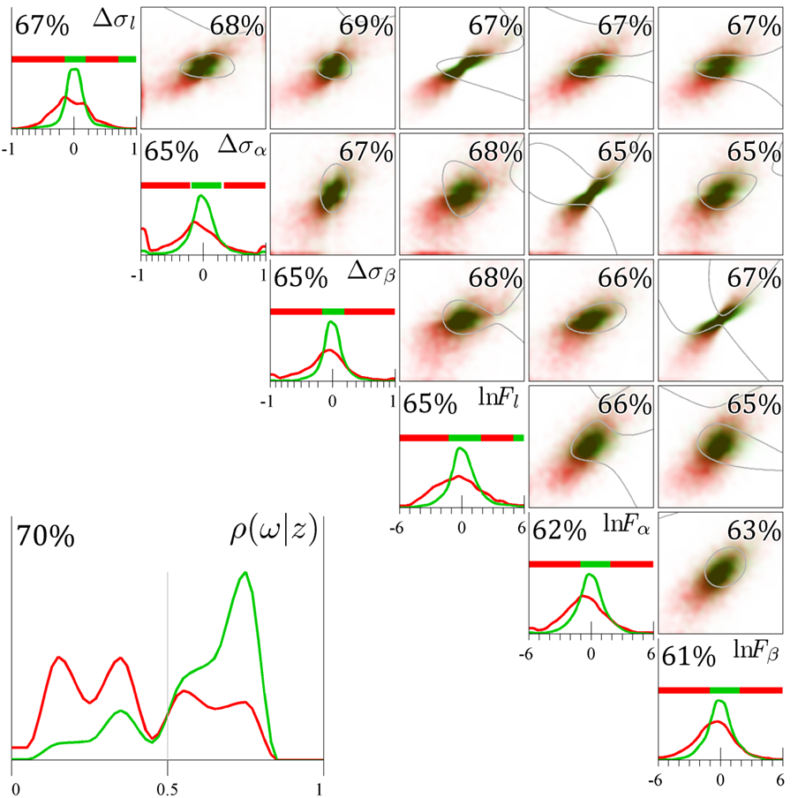

*ρ*( *c* | *y* )

Figure 8. Ground-truth distributions for category *same* (green) and *different* (red) are illustrated. Six properties are shown and the separation between patch centers is 1/4 leaf diameter. Along the diagonal, univariate histograms for each individual image property are shown with a univariate decision rule (indicated by the *red*-*green* tape) and training accuracy. In the upper-right triangle, bivariate scatterplots of the data are shown with gray contours indicating 2D classification boundaries (based on a cubic polynomial kernel) with training accuracies. Truncated mass is piled at the edges of the 1D histograms and 2D scatterplots. In the lower-left corner, histograms of conditional probability estimates $ρ(c|y)$ from a 6D model classifier (based on a cubic polynomial kernel) are shown with training accuracy. The testing accuracy for this 6D classifier was 70%. This figure was taken from Ing (2010) which can be referenced for further explanation.

Figure 9 illustrates how MoRPE was applied to solve the foreground-background classification problem illustrated in figure 6B.

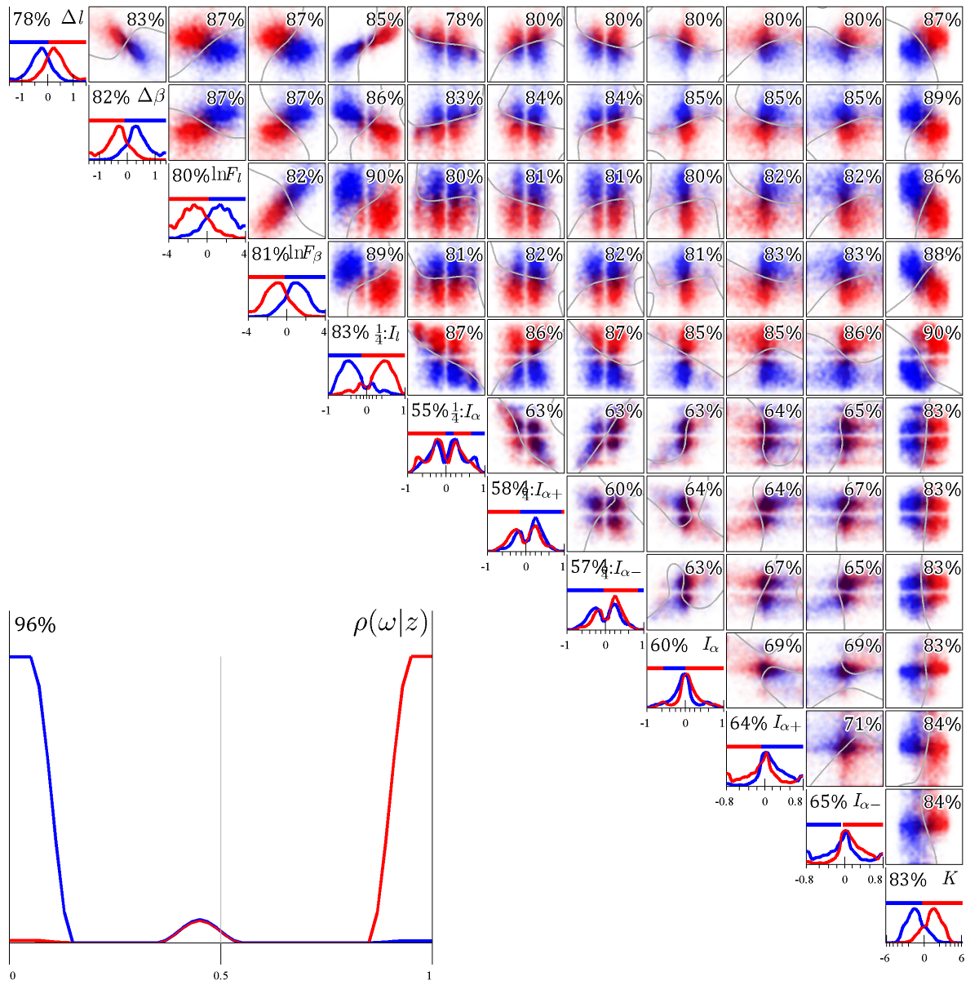

*ρ*( *c* | *y* )

Figure 9. Ground-truth distributions for category *foreground* (red) and *background* (blue) are illustrated. Twelve properties are shown based on contours of 1/4 length. Along the diagonal, univariate histograms for each individual image property are shown with a univariate decision rule (indicated by the red-blue tape) and training accuracy. In the upper-right triangle, bivariate scatterplots of the data are shown with gray contours indicating 2D classification boundaries (based on a cubic polynomial kernel) with training accuracies. Truncated mass is piled at the edges of the 1D histograms and 2D scatterplots. In the lower-left corner, histograms of conditional probability estimates $ρ(c|y)$ from a 12D model classifier (based on a cubic polynomial kernel) are shown with training accuracy. The testing accuracy for this 12D classifier was 94% and chance is 50%. This figure was taken from Ing (2010) which can be referenced for further explanation.

Figure 10 illustrates how MoRPE was applied to solve the boundary-marking-shadow classification problem illustrated in figure 6C.

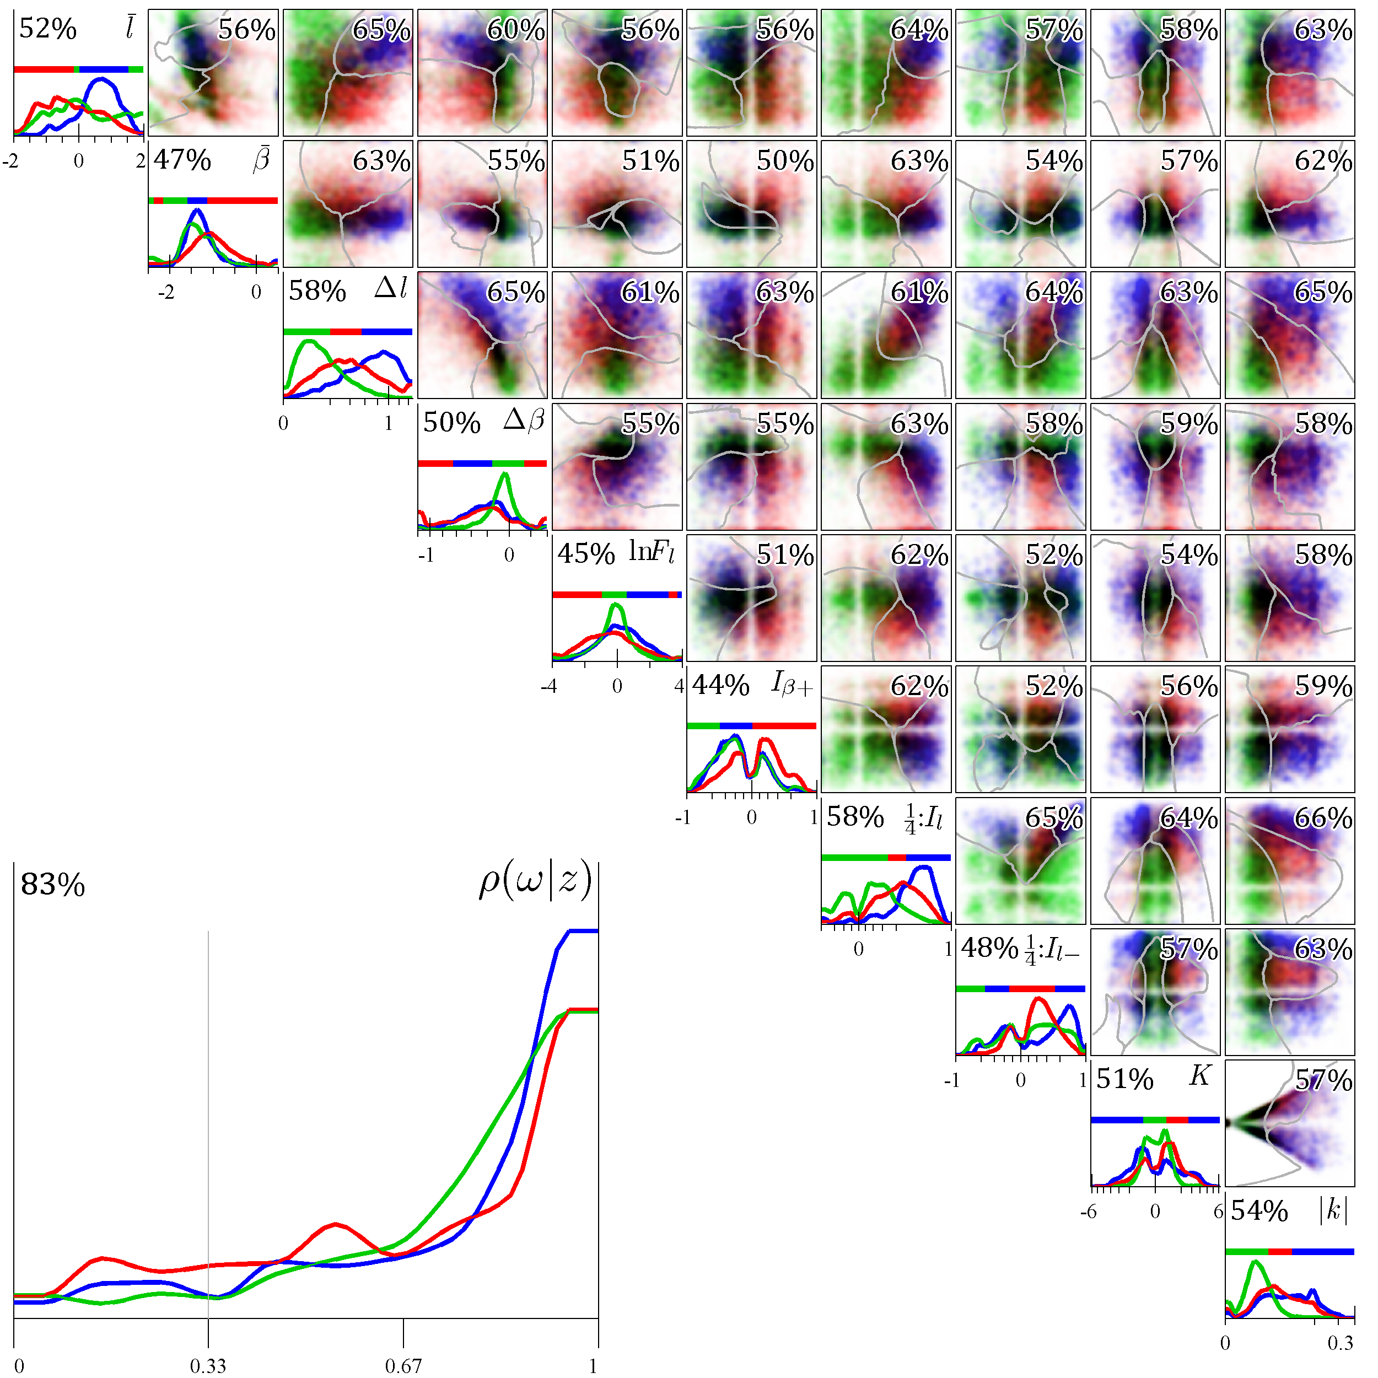

*k*

*ρ*( *c* | *y* )

Figure 10. Ground-truth distributions for category *boundary* (red), *marking* (green), and *shadow* (blue) are illustrated. Ten properties are shown based on patches with a diameter of 32 pixels or 74 minutes of arc. Along the diagonal, univariate histograms for each individual image property are shown with a univariate decision rule (indicated by the red-blue tape) and training accuracy. In the upper-right triangle, bivariate scatterplots of the data are shown with gray contours indicating 2D classification boundaries (based on a cubic polynomial kernel) with training accuracies. Truncated mass is piled at the edges of the 1D histograms and 2D scatterplots. In the lower-left corner, histograms of conditional probability estimates $ρ(c|y)$ from a 10D model classifier (based on a cubic polynomial kernel) are shown with training accuracy. The testing accuracy for this 10D classifier was 77% and chance is 33%. This figure was taken from Ing (2010) which can be referenced for further explanation.

While Ing (2010) applied MoRPE to study classification problems in one specific area (perceptual systems), similar problems can be found at the heart of many applications in science and engineering. Moreover, many statistical tests can be improved (even revolutionized) by leveraging a nearly optimal classifier like MoRPE.

# Appendix A

This appendix proves an assertion: If we are given a two-category problem in probabilistic classification, and if the probability distribution of each category is expressed as an exponentiated *R*-th order polynomial, then the optimal probabilistic classifier can be expressed as a function of another *R*-th order polynomial.

Let us define two vectors of polynomial coefficients $a_{1}$ and $a_{2}$ and two normalizing scalars $k_{1}$ and $k_{2}$. We formalize the given information as follows.

$$\dot{p}\left(1 | \text{x}\right)≡k_{1}exp\left[a_{1}∙h_{R}\left(x\right)\right]$$

$$\dot{p}\left(2 | \text{x}\right)≡k_{2}exp\left[a_{2}∙h_{R}\left(x\right)\right]$$

We want to compute *y* because that will allow us to define an optimal classifier (later).

$$y≡ ln\frac{\dot{p}\left(1 | \text{x}\right)}{\dot{p}\left(2 | \text{x}\right)}$$

Substitute.

$$y≡ln\left(\frac{k_{1}exp\left[a_{1}∙h_{R}\left(x\right)\right]}{k_{2}exp\left[a_{2}∙h_{R}\left(x\right)\right]}\right)$$

Assert the rule that $ln(o_{1}∙o_{2})=ln(o_{1})+ln(o_{2})$ for some variables $o_{1}$ and $o_{2}$.

$$y≡ln\left(\frac{exp\left[a_{1}∙h_{R}\left(x\right)\right]}{exp\left[a_{2}∙h_{R}\left(x\right)\right]}\right)+ln\left(\frac{k_{1}}{k_{2}}\right)$$

Assert the rule that $ln(o_{1}/o_{2})=ln(o_{1})-ln(o_{2})$ for some variables $o_{1}$ and $o_{2}$.

$$y≡ln\left(exp\left[a_{1}∙h_{R}\left(x\right)\right]\right)-ln\left(exp\left[a_{2}∙h_{R}\left(x\right)\right]\right)+ln\left(\frac{k_{1}}{k_{2}}\right)$$

Assert the rule that $o = ln[exp(o)]$ for some variable *o*.

$$y≡a_{1}∙h_{R}\left(x\right)-a_{2}∙h_{R}\left(x\right)+ln\left(\frac{k_{1}}{k_{2}}\right)$$

It is trivial to demonstrate that the preceding expression can be simplified to another polynomial with some arbitrary coefficients $a_{3}$.

$$y≡a_{3}∙h_{R}\left(x\right)$$

The optimal classifier is $p\left(1 | \text{x}\right)$ and it can be defined in terms of a logistic sigmoid function. This is a well-known property of log-likelihood ratios for the 2-category classification problem.

$$p\left(1 | \text{x}\right)= \frac{1}{1+exp\left(- ln\frac{\dot{p}\left(1 | \text{x}\right)}{\dot{p}\left(2 | \text{x}\right)}\right)}$$

Substitute *y*.

$$p\left(1 | \text{x}\right)= \frac{1}{1+exp\left(-y\right)}$$

Therefore, the optimal classifier is a function of *y* which is just an *R*-th order polynomial function of **x**. The assertion is proved.

# Appendix B

This appendix shows how Fisher’s Quadratic Discriminant (the FQD) is derived. We begin by setting the FQD equal to *y* in the statement below.

$$y≡ ln\frac{\dot{p}\left(1 | \text{x}\right)}{\dot{p}\left(2 | \text{x}\right)}$$

Fisher assumes that both probability density functions are Gaussian, so make the appropriate substitution.

$$y≡ln\left(\frac{\frac{1}{{(2π)}^{D/2}{|Σ_{1}|}^{1/2}}exp\left[-\frac{1}{2}{(x-μ_{1})}^{T}Σ_{1}^{-1}(x-μ_{1})\right]}{\frac{1}{{(2π)}^{D/2}{|Σ_{2}|}^{1/2}}exp\left[-\frac{1}{2}{(x-μ_{2})}^{T}Σ_{2}^{-1}(x-μ_{2})\right]}\right)$$

Cancel the scalars.

$$y≡ ln\left(\frac{exp\left[-\frac{1}{2}{(x-μ_{1})}^{T}Σ_{1}^{-1}(x-μ_{1})\right]}{exp\left[-\frac{1}{2}{(x-μ_{2})}^{T}Σ_{2}^{-1}(x-μ_{2})\right]}\right)-\frac{1}{2}ln\frac{|Σ_{1}|}{|Σ_{2}|}$$

Assert the rule that $ln(o_{1}/o_{2})=ln(o_{1})-ln(o_{2})$ for some variables $o_{1}$ and $o_{2}$.

$$y≡ ln\left(exp\left[-\frac{1}{2}{(x-μ_{1})}^{T}Σ_{1}^{-1}(x-μ_{1})\right]\right)-ln\left(exp\left[-\frac{1}{2}{(x-μ_{2})}^{T}Σ_{2}^{-1}(x-μ_{2})\right]\right)-\frac{1}{2}ln\frac{|Σ_{1}|}{|Σ_{2}|}$$

Assert the rule that $o = ln[exp(o)]$ for some variable *o*.

$$y≡ \frac{1}{2}{\left(x-μ_{2}\right)}^{T}Σ_{2}^{-1}\left(x-μ_{2}\right)-\frac{1}{2}{\left(x-μ_{1}\right)}^{T}Σ_{1}^{-1}\left(x-μ_{1}\right)-\frac{1}{2}ln\frac{|Σ_{1}|}{|Σ_{2}|}$$

Simplify the polynomial to get Fisher’s formula for the FQD.

$$y≡ \frac{1}{2}x^{T}\left(Σ_{1}^{-1}-Σ_{2}^{-1}\right)x+\left({μ_{2}^{T}Σ}_{2}^{-1}-{μ_{1}^{T}Σ}_{1}^{-1}\right)x+{μ_{1}^{T}Σ}_{1}^{-1}μ_{1}+{μ_{2}^{T}Σ}_{2}^{-1}μ_{2}-\frac{1}{2}ln\frac{|Σ_{1}|}{|Σ_{2}|}$$

# Appendix C

This appendix is a quick-reference to aid a reader’s ability to understand algebra and nomenclature of this document. Inside this appendix, the English letter *o* is an anonymous character.

## Notations, accents, symbols, and special functions

$o$ An italicized lowercase letter represents a single (non-tensor) variable.

$O$ An italicized uppercase letter represents a single (non-tensor) integer or a set of integers.

$o$ A bold lowercase letter represents a tall vector or a 1D tensor.

$O$ A bold uppercase letter represents a matrix or a 2D tensor.

$|O|$ A bold uppercase letter surrounded by vertical bars is the determinant of matrix $O$.

$\left\lceil o\right\rceil$ An overbracket represents ceiling of $o$ or the nearest integer value above $o$.

$R^{O}$ The infinite set of all *O*-dimensional real valued vectors.

$o^{T}$ The transpose operator (superscript *T*) applied to a bold lowercase letter represents a wide vector that is equal to the vector transpose of a tall vector.

$O^{T}$ The transpose operator (superscript *T*) applied to a bold uppercase letter represents a matrix transpose.

## English letters

$a$ Free parameters (polynomial coefficients), a vector $R^{H}$.

$b$ An arbitrary central bias parameter, implemented here as $b=1/2$.

$c$ An integer that represents a discrete category label.

$¬c$ The set of all categories not including category *c*.

$D$ Spatial dimensionality of feature space, equal to the length of $x$.

$f(.)$ Logistic sigmoid function.

$g(.)$ Multivariate polynomial function.

$h_{R}(.)$ An *R*-th order polynomial expansion used to define the axes of a Hilbert space. Outputs a vector $R^{H}$.

$H$ Spatial dimensionality of scene properties in Hilbert space, equal to the length of $z$.

$i$ An indexer. Sometimes refers to the *i*-th sample of data.

$j$ An indexer. Sometimes refers to the *j*-th quantile.

$k$ A coefficient that normalizes the scale of a probability density function so that total probability sums to 1.

$M$ Number of categories.

$N$ Number of data from all categories in a sample.

$N_{c}$ Number of data from category *c* in a sample.

$p(c)$ The prior probability (a.k.a. base-rate) of category $c$.

$p(c|x)$ The conditional probability of category $c$ given features $x$.

$p(c|y)$ The conditional probability of category $c$ given $y$.

$q(o)$ A quantization function that maps a $R^{1}$ input value ($o$) to a $R^{1}$ output value. The output is a number in the range $\left[1/{2N}, 1-1/{2N}\right]$ and represents the probability of observing an input value that is less than or equal to $o$ in a training sample.

$Q$ Arbitrary number of quantiles.

$R$ Rank of polynomial expansion.

$w_{c}$ A weighting factor for category *c*.

$x$ The signal vector in some feature space, vector $R^{D}$.

$y$ The decision variable given by the function $g(x,a)$, a scalar $R^{1}$.

$$y→g\left(x,a\right)=a∙{h_{R}\left(x\right)}^{T}=a∙z^{T}$$

$z$ Features cast into a Hilbert space using the polynomial expansion, a vector $R^{H}$.

## Greek letters

$ρ(c|x,a)$ MoRPE’s primary output. Also MoRPE’s estimate of the conditional probability of category $c$ for a given coordinate in feature space **x** using parameters **a**. This notation is used for the 2-category problem because parameters **a** are arranged as a vector.

$ρ(c|x,A)$ Same as above, but parameters **A** are arranged as a matrix for problems with more than 2 categories.

$ρ_{c}(c|x,a_{c})$ If the number of categories $M>2$, then $M$ distinct 2-category versions of MoRPE can be estimated. The subscript $c$ indicates the $c$–th 2-category classifier where $c∈\{1,…,M\}$. Otherwise, same as above.

$\tilde{ρ}$ MoRPE’s first estimate of $ρ$. Based on quantization but not monotonic regression.

$Σ$ Covariance matrix of a population.

$μ$ Mean vector of a population.

# References

Arfken GB & Weber HJ (2005) *Mathematical methods for physicists, sixth edition*. Burlington, MA, USA: Elsevier Inc.

Ashby FG (1992) Multivariate probability distributions. In F.G. Ashby (Ed.), *Multidimensional models of perception and cognition* (pp. 1-34). Mahwah, NJ: Erlbaum.

Bishop CM (2006) *Pattern recognition and machine learning*. New York, NY, USA: Springer.

Cortes C & Vapnik V (1995) Support-Vector Networks, *Machine Learning*, 20.

Cox DR (2006) *Principles of Statistical Inference*. Cambridge, UK: Cambridge University Press.

Dantzig GB (1963) Linear Programming and Extensions, Princeton University Press, Princeton, NJ.

Fisher RA (1936) The use of multiple measurements in taxonomic problems. *Annals of Eugenics* 7:179-188.

Foster M (1961) An application of the Wiener-Kolmogorov smoothing theory to matrix inversion, *J. SIAM* 9:387-392.

Hastie T, Tibshirani R, Friedman J (2008) *The Elements of Statistical Learning, Second Edition*. New York, NY, USA: Springer.

Hoerl AE (1962) Application of ridge analysis to regression problems. *Chemical Engineering Progress* 58:54-59.

Ing AD (2010) The leaf identification problem: Natural scene statistics and human performance. PhD Dissertation: The University of Texas at Austin, USA.

MacKay DJC (2003) *Information Theory, Inference, and Learning Algorithms*. Cambridge, UK: Cambridge University Press. ISBN 0-521-64298-1.

Platt JC (2000) Probabilities for SV machines. In AJ Smola, PL Bartlett, B Scholkopf, and D Schuurmans (Eds.) *Advances in Large Margin Classifiers* pp. 61–74. Cambridge, MA, USA: MIT Press.

Press WH, Teukolsky SA, Vetterling WT, Flannery BP (2002) *Numerical Recipes in C++, Second Edition*. Cambridge, MA, USA: Cambridge University Press.

Tipping ME (2001) Sparse Bayesian learning and the relevance vector machine. *Journal of Machine Learning Research* 1:211–244.

1. I do not offer support for this claim inside this manuscript. In order to support such a claim, I would need to simulate a representative sample of “common scenarios,” which is not a trivial exercise.
2. Later I offer an operational definition for the term *common scenario*.
3. The term *sampling noise* is defined as all properties of a finite sample that are different from a source population.
4. Later I give reasons for choosing the multivariate polynomial family of functions. The rationale is based on an understanding of the statistical moments of a multivariate probability distribution.
5. Later I assert *y* should be defined as a multivariate polynomial function of **x**.
6. Examples of sigmoid-based classifiers include the FQD, logistic regression, some variations of ridge regression, a probabilistic version of the SVM (Platt 2000), and the RVM. Perhaps their widespread usage is partially based on the relationship between the FQD and the logistic sigmoid function (see eq. 5).
7. In practice, the value of *R* is a positive integer that is uniquely determined for any given sample by utilizing a cross-validation procedure (e.g. Hastie et al. 2008 §7.10) to isolate the value of *R* that maximizes classifier performance.
8. MoRPE uses the *inhomogeneous* polynomial expansion (as opposed to *homogeneous*).
9. The vector space of **z** is a Hilbert space of dimensionality *H*.
10. The principles are similar to how *spherical* *multipole moments* describe the distribution of electric, magnetic, or gravitational potential using a 3D polynomial expansion called the *multipole expansion* (e.g. Arfken & Weber 2005 §9.7). This can be generalized to any dimensionality by utilizing multivariate polynomials (e.g. Arfken & Weber 2005 §12). This technique appears to be under-utilized or ignored by many researchers, but it is still a valid way of describing the shape of a multivariate probability distribution.
11. This statement assumes that the base rate of each category is equal.
12. The classifier is *confident* when $ρ(c|.)→1$ for one possible value of *c* (and zero for all other possible values).
13. This is guaranteed by the technique of quantization and monotonic regression.
14. This can be seen by relating equation 13 to the binary entropy function (MacKay 2003) and considering its derivative with respect to $ρ(.)$. This derivative has the greatest magnitude when $p(.)$ and $ρ(.)$ are both near extreme values (0 and 1). Note that $p(.)$ and $ρ(.)$ are guaranteed to be nearly equal (because of quantization), although $p(.)$ and $ρ(.)$ may differ slightly (because of monotonic regression).
15. Why does sampling noise low when $ρ(.)$ is extreme? This phenomenon is described by a canonical multinomial probability distribution. Extreme values of $ρ(.)$ can only be generated when some quantile is completely populated or unpopulated by some category. In such cases, sampling noise tends to be very low.
16. These errors are also diminished by usage of the quantization technique with monotonic regression.